透過Visual C++配合Open GL實現機器手臂動作模擬(2)(完)
前言：
就如同作者在前一篇文章『透過Visual C++配合Open GL實現機器手臂動作模擬(1)』的結論所說，由於上ㄧ篇文章篇幅關係，因此將所有程式介紹在這一篇文章來做說明。
- 自定基本Open GL繪圖元件函數程式碼說明：
再這一部份，作者要延續上一篇文章的第三章的第一節之內容詳細介紹相關自定的基本繪圖元件的函數，以下作者將分成『理論』與『程式』兩個部份來說明，其原因是在程式當中會參雜著「向量」與「矩陣」等數學運算存在，因此在此作者會先說明相關數學運算式，之後再就動作流程部分說明以較完整的方式完成理論的介紹，最後才是對程式作註解說明(ps：講到這一些自定的繪圖元件，首先要在這裡感謝我的研究所學長，因為是他寫出來給我們這些懶惰的學弟使用，而我只是借花獻佛，又再度把它拿來和大家分享而已，因此如果各位讀者有更好更棒的寫法也希望能與作者分享)。
1.1相關理論介紹
- 矩陣行列式運算
A-1. 2*2行列式運算
矩陣
B= | b1 b2 |
| b3 b4 |

則|B|=b1*b4-b2*b3
Ex:
C= | 1 2 |
| 3 4 |

則|C|=4-6=2
A-2.3*3行列式運算
| b1 b2 b3 |
B= | b4 b5 b6 |
| b7 b8 b9 |

則|B|=(b1*b5*b9)+(b4*b8*b3)+(b2*b6*b7)-(b3*b5*b7)-(b2*b4*b9)-(b1*b6*b8)
Ex:
| +1 +2 +5 |
B= | +4 -1 -6 |
| +9 -3 +2 |

則|B|= -159
- 向量
B-1向量表示
向量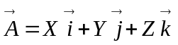
B-2單位向量
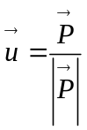
B-3向量外積
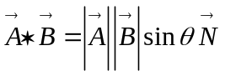
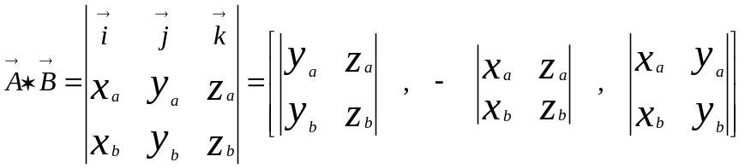
Ex:
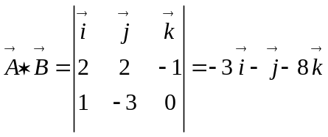
1.2動作流程分析
- 依照傳入參數計算出每個立體物件的每個面的頂點值。
Ex:立方體計算頂點，假設傳入長寬高等參數
///依照傳入參數計算多邊形的頂點
float v[4][3] = {{ W/2, L/2, H/2},
{ -W/2, L/2, H/2},
{ -W/2,-L/2, H/2},
{ W/2,-L/2, H/2}};

- 計算每個平面的新的起始座標系，並透過指令設定新的座標系。
Ex:立方體計算頂點，假設傳入長寬高等參數
//計算該平面的基準座標系
calcNormal(v,normal);
//設定基準座標系
glNormal3fv(normal);
- 依照每個平面的頂點執繪製該平面。
Ex:立方體計算頂點，假設傳入長寬高等參數
//透過Open GL的功能建置該平面
glVertex3fv(v[0]);
glVertex3fv(v[1]);
glVertex3fv(v[2]);
glVertex3fv(v[3]);
1.3 函數宣告與程式碼註解說明如下：
函數名稱 | void ReduceToUnit(float vector[3]);
功能 | 計算單位向量
程式碼 | void ReduceToUnit(float vector[3])  {  float length;  //計算該向量長度  length = (float)sqrt((vector[0]*vector[0]) +  (vector[1]*vector[1]) +  (vector[2]*vector[2]));  //判斷向量長度是匪為0  if(length == 0.0f)  {  length = 1.0f;  }  //計算單位向量  vector[0] /= length;  vector[1] /= length;  vector[2] /= length;  }
函數名稱 | void calcNormal(float v[3][3], float out[3]);
功能 | 計算單位法向量
程式碼 | void calcNormal(float v[3][3], float out[3])  {  float v1[3],v2[3];  static const int x = 0;  static const int y = 1;  static const int z = 2;  // 計算傳入三個點資料參數的向量值  v1[x] = v[0][x] - v[1][x];  v1[y] = v[0][y] - v[1][y];  v1[z] = v[0][z] - v[1][z];  v2[x] = v[1][x] - v[2][x];  v2[y] = v[1][y] - v[2][y];  v2[z] = v[1][z] - v[2][z];  // 計算兩向量的X積  out[x] = v1[y]*v2[z] - v1[z]*v2[y];  out[y] = v1[z]*v2[x] - v1[x]*v2[z];  out[z] = v1[x]*v2[y] - v1[y]*v2[x];  //計算該向量的單位向量  ReduceToUnit(out);  }
函數名稱 | void drawRetc(float W,float L,float H);
功能 | 繪製長方柱體
程式碼 | void drawRetc(float W,float L,float H)  {  float normal[3];  glBegin(GL_QUADS);//匯至四邊形起始指令  {  ///依照傳入參數計算多邊形的頂點  float v[4][3] = {{ W/2, L/2, H/2},  { -W/2, L/2, H/2},  { -W/2,-L/2, H/2},  { W/2,-L/2, H/2}};  //計算該平面的基準座標系  calcNormal(v,normal);  //設定基準座標系  glNormal3fv(normal);  //透過Open GL的功能建置該平面  glVertex3fv(v[0]);  glVertex3fv(v[1]);  glVertex3fv(v[2]);  glVertex3fv(v[3]);  }  {  //依照傳入參數計算多邊形的頂點  float v[4][3] = {{ W/2, L/2, H/2},  { W/2,-L/2, H/2},  { W/2,-L/2,-H/2},  { W/2, L/2,-H/2}};  //計算該平面的基準座標系  calcNormal(v,normal);  //設定基準座標系  glNormal3fv(normal);  //透過Open GL的功能建置該平面  glVertex3fv(v[0]);  glVertex3fv(v[1]);  glVertex3fv(v[2]);  glVertex3fv(v[3]);  }  {  //依照傳入參數計算多邊形的頂點  float v[4][3] = {{ W/2, L/2, H/2},  { W/2, L/2,-H/2},  { -W/2, L/2,-H/2},  { -W/2, L/2, H/2}};  //計算該平面的基準座標系  calcNormal(v,normal);  //設定基準座標系  glNormal3fv(normal);  //透過Open GL的功能建置該平面  glVertex3fv(v[0]);  glVertex3fv(v[1]);  glVertex3fv(v[2]);  glVertex3fv(v[3]);  }  {  //依照傳入參數計算多邊形的頂點  float v[4][3] = {{-W/2, L/2, H/2},  { -W/2, L/2,-H/2},  { -W/2,-L/2,-H/2},  { -W/2,-L/2, H/2}};  //計算該平面的基準座標系  calcNormal(v,normal);  //設定基準座標系  glNormal3fv(normal);  //透過Open GL的功能建置該平面  glVertex3fv(v[0]);  glVertex3fv(v[1]);  glVertex3fv(v[2]);  glVertex3fv(v[3]);  }  {  //依照傳入參數計算多邊形的頂點  float v[4][3] = {{-W/2,-L/2, H/2},  { -W/2,-L/2,-H/2},  { W/2,-L/2,-H/2},  { W/2,-L/2, H/2}};  //計算該平面的基準座標系  calcNormal(v,normal);  //設定基準座標系  glNormal3fv(normal);  //透過Open GL的功能建置該平面  glVertex3fv(v[0]);  glVertex3fv(v[1]);  glVertex3fv(v[2]);  glVertex3fv(v[3]);  }  {  //依照傳入參數計算多邊形的頂點  float v[4][3] = {{ W/2, L/2,-H/2},  { W/2,-L/2,-H/2},  { -W/2,-L/2,-H/2},  { -W/2, L/2,-H/2}};  //計算該平面的基準座標系  calcNormal(v,normal);  //設定基準座標系  glNormal3fv(normal);  //透過Open GL的功能建置該平面  glVertex3fv(v[0]);  glVertex3fv(v[1]);  glVertex3fv(v[2]);  glVertex3fv(v[3]);  }  glEnd();//匯至四邊形結束指令  }
函數名稱 | void drawCir(float radius, float L, int segment);
功能 | 繪製園柱體
程式碼 | //建構步驟說明同上  void drawCir(float radius, float L, int segment)  {  float angle[2];  float normal[3];  glBegin(GL_QUADS);  {  for(angle[0]=0.0f, angle[1]=0.0f; angle[0]< (2.0f*GL_PI); angle[0]+=((2.0f*GL_PI)/segment))  {  float r[4][3] = {{radius*(float)cos(angle[1]), radius*(float)sin(angle[1]), L/2},  { radius*(float)cos(angle[1]), radius*(float)sin(angle[1]),-L/2},  { radius*(float)cos(angle[0]), radius*(float)sin(angle[0]),-L/2},  { radius*(float)cos(angle[0]), radius*(float)sin(angle[0]), L/2}};  calcNormal(r,normal);  glNormal3fv(normal);  glVertex3fv(r[0]);  glVertex3fv(r[1]);  glVertex3fv(r[2]);  glVertex3fv(r[3]);  angle[1]=angle[0];  }  }  glEnd();  glBegin(GL_TRIANGLE_FAN);  {  glVertex3f(0.0f, 0.0f, L/2);  for (angle[1]=0.0f, angle[0]=0.0f; angle[1]<=(2.0f*GL_PI); angle[0]+=((2.0f*GL_PI)/segment))  {  float x=radius*(float)cos(angle[0]);  float y=radius*(float)sin(angle[0]);  float v[3][3] = {{0.0f , 0.0f , L/2},  { radius*(float)cos(angle[1]), radius*(float)sin(angle[1]), L/2},  { radius*(float)cos(angle[0]), radius*(float)sin(angle[0]), L/2}};  calcNormal(v,normal);  glNormal3fv(normal);  glVertex3f(x, y, L/2);  angle[1]=angle[0];  }  }  glEnd();  glBegin(GL_TRIANGLE_FAN);  {  glVertex3f(0.0f, 0.0f,-L/2);  for (angle[1]=0.0f, angle[0]=0.0f; angle[1]<= (2.0f*GL_PI); angle[0]+=((2.0f*GL_PI)/segment))  {  float x=radius*(float)cos(angle[0]);  float y=radius*(float)sin(angle[0]);  float v[3][3] = {{0.0f , 0.0f ,-L/2},  { radius*(float)cos(angle[0]), radius*(float)sin(angle[0]),-L/2},  { radius*(float)cos(angle[1]), radius*(float)sin(angle[1]),-L/2}};  calcNormal(v,normal);  glNormal3fv(normal);  glVertex3f(x, y,-L/2);  angle[1]=angle[0];  }  }  glEnd();  }
函數名稱 | void drawtriangle(float W,float L,float H);
功能 | 繪製三角柱體
程式碼 | //建構步驟說明同上  void drawtriangle(float W,float L,float H)  {  static float normal[3];  glBegin(GL_QUADS);  {  float v[4][3] = {{ W/2, L/2, -H/2},  { -W/2, L/2, H/2},  { -W/2,-L/2, H/2},  { W/2,-L/2, -H/2}};  // Calculate the normal for the plane  calcNormal(v,normal);  glNormal3fv(normal);  glVertex3fv(v[0]);  glVertex3fv(v[1]);  glVertex3fv(v[2]);  glVertex3fv(v[3]);  }  {  float v[3][3] = {{ W/2, L/2, -H/2},  { -W/2,L/2, -H/2},  { -W/2,L/2,H/2}};  calcNormal(v,normal);  glNormal3fv(normal);  glVertex3fv(v[0]);  glVertex3fv(v[1]);  glVertex3fv(v[2]);  glVertex3fv(v[3]);  }  {  float v[4][3] = {{ -W/2, L/2, H/2},  { -W/2, L/2,-H/2},  { -W/2, -L/2,-H/2},  { -W/2, -L/2, H/2}};  calcNormal(v,normal);  glNormal3fv(normal);  glVertex3fv(v[0]);  glVertex3fv(v[1]);  glVertex3fv(v[2]);  glVertex3fv(v[3]);  }  {  float v[3][3] = {{-W/2, -L/2, H/2},  { -W/2, -L/2,-H/2},  { W/2,-L/2,-H/2}};  calcNormal(v,normal);  glNormal3fv(normal);  glVertex3fv(v[0]);  glVertex3fv(v[1]);  glVertex3fv(v[2]);  glVertex3fv(v[3]);  }  {  float v[4][3] = {{ W/2, L/2, -H/2},  { W/2, -L/2,-H/2},  { -W/2, -L/2,-H/2},  { -W/2, L/2, -H/2}};  calcNormal(v,normal);  glNormal3fv(normal);  glVertex3fv(v[0]);  glVertex3fv(v[1]);  glVertex3fv(v[2]);  glVertex3fv(v[3]);  }  glEnd();  }
函數名稱 | void drawtriangle_1(float W,float L,float H);
功能 | 繪製三角柱體1
程式碼 | //建構步驟說明同上  void drawtriangle_1(float W,float L,float H)  {  static float normal[3];  glBegin(GL_QUADS);  {  float v[4][3] = {{ W/2, -L/2, H/2},  { W/2, L/2, H/2},  { -W/2,L/2, -H/2},  { -W/2,-L/2, -H/2}};  // Calculate the normal for the plane  calcNormal(v,normal);  glNormal3fv(normal);  glVertex3fv(v[0]);  glVertex3fv(v[1]);  glVertex3fv(v[2]);  glVertex3fv(v[3]);  }  {  float v[3][3] = {{ W/2, L/2, H/2},  { W/2,L/2, -H/2},  { -W/2,L/2,-H/2}};  calcNormal(v,normal);  glNormal3fv(normal);  glVertex3fv(v[0]);  glVertex3fv(v[1]);  glVertex3fv(v[2]);  glVertex3fv(v[3]);  }  {  float v[4][3] = {{ W/2, L/2, H/2},  { W/2, -L/2,H/2},  { W/2, -L/2,-H/2},  { W/2, L/2, -H/2}};  calcNormal(v,normal);  glNormal3fv(normal);  glVertex3fv(v[0]);  glVertex3fv(v[1]);  glVertex3fv(v[2]);  glVertex3fv(v[3]);  }  {  float v[3][3] = {{W/2, -L/2, H/2},  { -W/2,-L/2,-H/2},  { W/2, -L/2,-H/2}};  calcNormal(v,normal);  glNormal3fv(normal);  glVertex3fv(v[0]);  glVertex3fv(v[1]);  glVertex3fv(v[2]);  glVertex3fv(v[3]);  }  {  float v[4][3] = {{ -W/2, L/2, -H/2},  { W/2, L/2,-H/2},  { W/2, -L/2,-H/2},  { -W/2, -L/2, -H/2}};  calcNormal(v,normal);  glNormal3fv(normal);  glVertex3fv(v[0]);  glVertex3fv(v[1]);  glVertex3fv(v[2]);  glVertex3fv(v[3]);  }  glEnd();  }
函數名稱 | void drawladder(float U,float L,float H,float W);
功能 | 繪製梯形柱體
程式碼 | //建構步驟說明同上  void drawladder(float U,float L,float H,float W)  {  // if(Line_Side==false)  // {  static float normal[3];  glBegin(GL_QUADS);  {  float v[4][3] = {{ U/2, W/2, H/2},  { -U/2, W/2, H/2},  { -U/2,-W/2, H/2},  { U/2,-W/2, H/2}};  // Calculate the normal for the plane  calcNormal(v,normal);  glNormal3fv(normal);  glVertex3fv(v[0]);  glVertex3fv(v[1]);  glVertex3fv(v[2]);  glVertex3fv(v[3]);  }  {  float v[4][3] = {{ U/2, -W/2, H/2},  { -U/2,-W/2, H/2},  { -L/2,-W/2,-H/2},  { L/2,-W/2,-H/2}};  calcNormal(v,normal);  glNormal3fv(normal);  glVertex3fv(v[0]);  glVertex3fv(v[1]);  glVertex3fv(v[2]);  glVertex3fv(v[3]);  }  {  float v[4][3] = {{ U/2, W/2, H/2},  { U/2, -W/2,H/2},  { L/2, -W/2,-H/2},  { L/2, W/2, -H/2}};  calcNormal(v,normal);  glNormal3fv(normal);  glVertex3fv(v[0]);  glVertex3fv(v[1]);  glVertex3fv(v[2]);  glVertex3fv(v[3]);  }  {  float v[4][3] = {{U/2, W/2, H/2},  { -U/2, W/2,H/2},  { -L/2, W/2,-H/2},  { L/2, W/2,-H/2}};  calcNormal(v,normal);  glNormal3fv(normal);  glVertex3fv(v[0]);  glVertex3fv(v[1]);  glVertex3fv(v[2]);  glVertex3fv(v[3]);  }  {  float v[4][3] = {{-U/2,W/2, H/2},  { -U/2,-W/2,H/2},  { -L/2,-W/2,-H/2},  { -L/2,W/2,-H/2}};  calcNormal(v,normal);  glNormal3fv(normal);  glVertex3fv(v[0]);  glVertex3fv(v[1]);  glVertex3fv(v[2]);  glVertex3fv(v[3]);  }  {  float v[4][3] = {{ L/2, W/2,-H/2},  { -L/2, W/2,-H/2},  { -L/2,-W/2,-H/2},  { L/2,-W/2,-H/2}};  calcNormal(v,normal);  glNormal3fv(normal);  glVertex3fv(v[0]);  glVertex3fv(v[1]);  glVertex3fv(v[2]);  glVertex3fv(v[3]);  }  glEnd();  }
- 依序建購機器手臂
讀者看到這裡相信已經了解建構繪圖元件的方法與理論，因此如讀者還有想要建構的元件可依照上述方法自行設計，如此ㄧ來相信就可以擁有更好用屬於自己的函式庫；既然已介紹完如何繪製完元件之後，接下來就要開始進入建構機器手臂的程式實作了，在這一章內作者將會依照『底座』、『主幹1』、『主幹2』、『手臂1』、『手臂2』、『手臂2的半圓』、『手臂3』、『手掌』等部位依序建構，廢話不多說，就請各位讀者跟著作者的步驟一起見購機器手臂吧。
2.1 底座建立
建立機器手臂的底座的方法就是只要在自定User_Draw的函數中加入下列『粗體』程式碼，之後執行編譯即可，其結果如圖一所示：
void CGLbaseView::User_Draw()//第十四步
{
glPushMatrix();///區塊start
{
glTranslatef(0.0f,0.0f,0.0f);
glRotatef(view_x, 1.0f, 0.0f, 0.0f);//視角旋轉角度
glRotatef(view_y, 0.0f, 1.0f, 0.0f);//視角旋轉角度
glRotatef(view_z, 0.0f, 0.0f, 1.0f);//視角旋轉角度
glColor3ub(0.0f,0.0f,130.0f);//設顏色
drawRetc(1024.0f,768.0f,10.0f);//底板
}
glPopMatrix();///區塊end
//////////////////////////////////////////
}
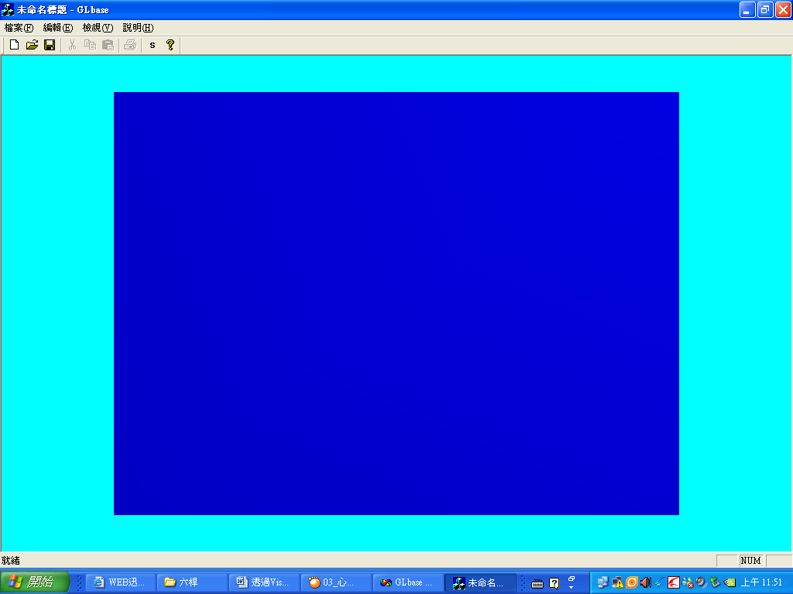
圖一：底板建立
2.2 主幹1建立
再建立底座後只要在自定User_Draw的函數加入下列『粗體』程式碼，並執行編譯，即可建立『主幹1』的部份，其結果如圖二所示：
void CGLbaseView::User_Draw()//第十四步
{
glPushMatrix();///區塊start
{
glTranslatef(0.0f,0.0f,0.0f);
glRotatef(view_x, 1.0f, 0.0f, 0.0f);//視角旋轉角度
glRotatef(view_y, 0.0f, 1.0f, 0.0f);//視角旋轉角度
glRotatef(view_z, 0.0f, 0.0f, 1.0f);//視角旋轉角度
glColor3ub(0.0f,0.0f,130.0f);//設顏色
drawRetc(1024.0f,768.0f,10.0f);//底板
glPushMatrix();///區塊start
{
glColor3ub(0.0f,130.0f,130.0f);
glTranslatef((1024.0f/2.0f-100.0f/2.0f),(768.0f/2.0f-100.0/2.0f),(10.0f/2.0f+200.0f/2.0f));
glTranslatef(trans_x,0.0,0.0);
glTranslatef(0.0,trans_y,0.0);
drawRetc(100.0f,100.0f,200.0f);//主幹1
glRotatef(Rotat1,0.0f,0.0f,1.0f);
}
glPopMatrix();///區塊end
}
glPopMatrix();///區塊end
//////////////////////////////////////////
}
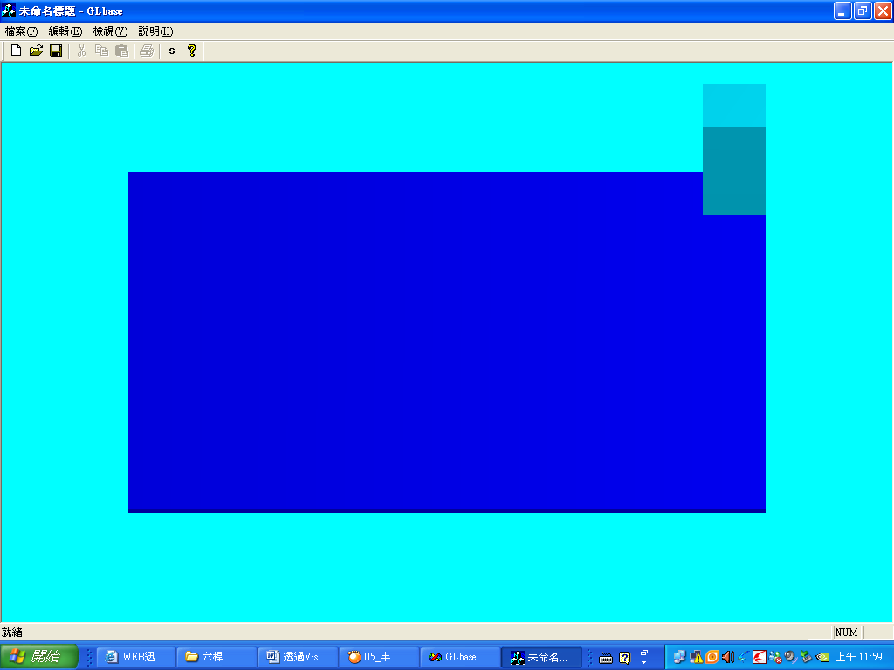
圖二；主幹1建立
2.3主幹2建立
再建立主幹1後只要在自定的User_Draw加入下列『粗體』程式碼，並執行編譯，即可建立『主幹2』的部份，其結果如圖三所示：
void CGLbaseView::User_Draw()//第十四步
{
glPushMatrix();///區塊start
{
glTranslatef(0.0f,0.0f,0.0f);
glRotatef(view_x, 1.0f, 0.0f, 0.0f);//視角旋轉角度
glRotatef(view_y, 0.0f, 1.0f, 0.0f);//視角旋轉角度
glRotatef(view_z, 0.0f, 0.0f, 1.0f);//視角旋轉角度
glColor3ub(0.0f,0.0f,130.0f);//設顏色
drawRetc(1024.0f,768.0f,10.0f);//底板
glPushMatrix();///區塊start
{
glColor3ub(0.0f,130.0f,130.0f);
glTranslatef((1024.0f/2.0f-100.0f/2.0f),(768.0f/2.0f-100.0/2.0f),(10.0f/2.0f+200.0f/2.0f));
glTranslatef(trans_x,0.0,0.0);
glTranslatef(0.0,trans_y,0.0);
drawRetc(100.0f,100.0f,200.0f);//主幹1
glRotatef(Rotat1,0.0f,0.0f,1.0f);
glPushMatrix();///區塊start
{
glColor3ub(0.0f,130.0f,30.0f);
glTranslatef(0.0f,0.0f,(200.0f/2.0f)+(200.0f/2.0f));
drawRetc(100.0f,100.0f,200.0f);//主幹2
}
glPopMatrix();///區塊end
}
glPopMatrix();///區塊end
}
glPopMatrix();///區塊end
//////////////////////////////////////////
}
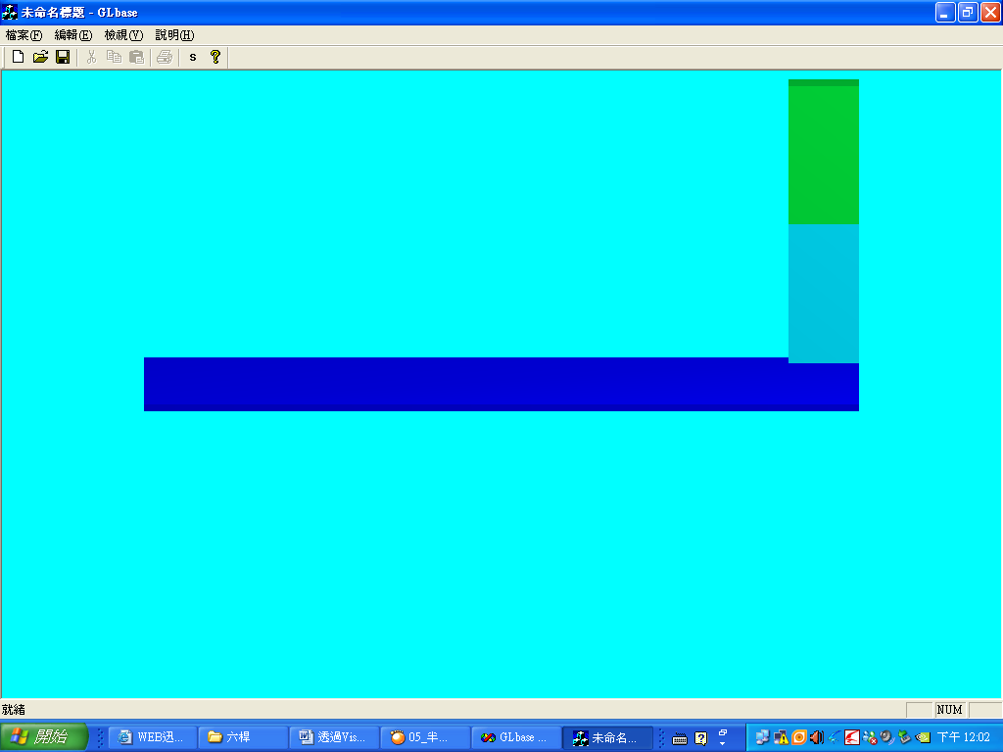
圖三；主幹2建立
2.4手臂1建立
再建立主幹2後只要在自定的User_Draw加入下列『粗體』程式碼，並執行編譯，即可建立『手臂1』的部份，其結果如圖四所示：
void CGLbaseView::User_Draw()//第十四步
{
glPushMatrix();///區塊start
{
glTranslatef(0.0f,0.0f,0.0f);
glRotatef(view_x, 1.0f, 0.0f, 0.0f);//視角旋轉角度
glRotatef(view_y, 0.0f, 1.0f, 0.0f);//視角旋轉角度
glRotatef(view_z, 0.0f, 0.0f, 1.0f);//視角旋轉角度
glColor3ub(0.0f,0.0f,130.0f);//設顏色
drawRetc(1024.0f,768.0f,10.0f);//底板
glPushMatrix();///區塊start
{
glColor3ub(0.0f,130.0f,130.0f);
glTranslatef((1024.0f/2.0f-100.0f/2.0f),(768.0f/2.0f-100.0/2.0f),(10.0f/2.0f+200.0f/2.0f));
glTranslatef(trans_x,0.0,0.0);
glTranslatef(0.0,trans_y,0.0);
drawRetc(100.0f,100.0f,200.0f);//主幹1
glRotatef(Rotat1,0.0f,0.0f,1.0f);
glPushMatrix();///區塊start
{
glColor3ub(0.0f,130.0f,30.0f);
glTranslatef(0.0f,0.0f,(200.0f/2.0f)+(200.0f/2.0f));
drawRetc(100.0f,100.0f,200.0f);//主幹2
glPushMatrix();///區塊start
{
glColor3ub(130.0f,30.0f,130.0f);
glTranslatef(100.0f/2.0f-300.0f/2.0f,(100.0f/2.0f+100.0f/2.0f),(200.0f/2.0f)-(100.0f/2.0f));
glTranslatef(300.0f/2.0f-100.0f/2.0f,0.0f,0.0f);
glRotatef(Rotat2,0.0f,1.0f,0.0f);
glTranslatef(-300.0f/2+100.0f/2.0f,0.0f,0.0f);
drawRetc(300.0f,100.0f,100.0f);//手臂1
}
glPopMatrix();///區塊end
}
glPopMatrix();///區塊end
}
glPopMatrix();///區塊end
}
glPopMatrix();///區塊end
//////////////////////////////////////////
}
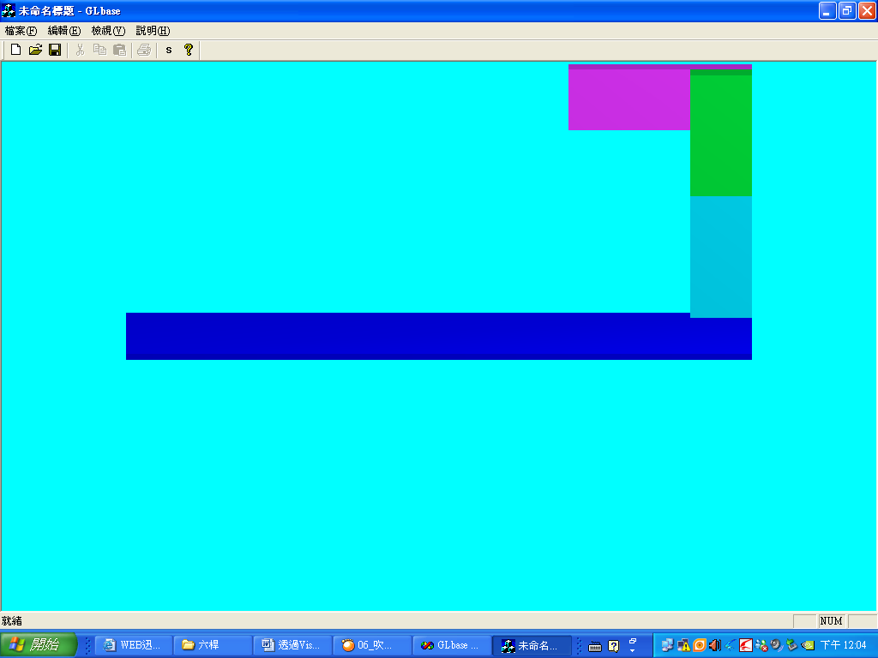
圖四；手臂1建立
2.5手臂2建立
再建立手臂1後只要在自定的User_Draw加入下列『粗體』程式碼，並執行編譯，即可建立『手臂1』的部份，其結果如圖五所示：
void CGLbaseView::User_Draw()//第十四步
{
glPushMatrix();///區塊start
{
glTranslatef(0.0f,0.0f,0.0f);
glRotatef(view_x, 1.0f, 0.0f, 0.0f);//視角旋轉角度
glRotatef(view_y, 0.0f, 1.0f, 0.0f);//視角旋轉角度
glRotatef(view_z, 0.0f, 0.0f, 1.0f);//視角旋轉角度
glColor3ub(0.0f,0.0f,130.0f);//設顏色
drawRetc(1024.0f,768.0f,10.0f);//底板
glPushMatrix();///區塊start
{
glColor3ub(0.0f,130.0f,130.0f);
glTranslatef((1024.0f/2.0f-100.0f/2.0f),(768.0f/2.0f-100.0/2.0f),(10.0f/2.0f+200.0f/2.0f));
glTranslatef(trans_x,0.0,0.0);
glTranslatef(0.0,trans_y,0.0);
drawRetc(100.0f,100.0f,200.0f);//主幹1
glRotatef(Rotat1,0.0f,0.0f,1.0f);
glPushMatrix();///區塊start
{
glColor3ub(0.0f,130.0f,30.0f);
glTranslatef(0.0f,0.0f,(200.0f/2.0f)+(200.0f/2.0f));
drawRetc(100.0f,100.0f,200.0f);//主幹2
glPushMatrix();///區塊start
{
glColor3ub(130.0f,30.0f,130.0f);
glTranslatef(100.0f/2.0f-300.0f/2.0f,(100.0f/2.0f+100.0f/2.0f),(200.0f/2.0f)-(100.0f/2.0f));
glTranslatef(300.0f/2.0f-100.0f/2.0f,0.0f,0.0f);
glRotatef(Rotat2,0.0f,1.0f,0.0f);
glTranslatef(-300.0f/2+100.0f/2.0f,0.0f,0.0f);
drawRetc(300.0f,100.0f,100.0f);//手臂1
glPushMatrix();///區塊start
{
glColor3ub(130.0f,30.0f,30.0f);
glTranslatef(-100.0f,0.0f,0.0f);
glRotatef(Rotat3,0.0f,1.0f,0.0f);
glTranslatef(100.0f,0.0f,0.0f);
glTranslatef(-300.0f/2-250.0f/2.0f+100.0f,-100.0f/2.0f-100.0f/2.0f,0.0f);
drawRetc(250.0f,100.0f,100.0f);//手臂2
}
glPopMatrix();///區塊end
}
glPopMatrix();///區塊end
}
glPopMatrix();///區塊end
}
glPopMatrix();///區塊end
}
glPopMatrix();///區塊end
//////////////////////////////////////////
}
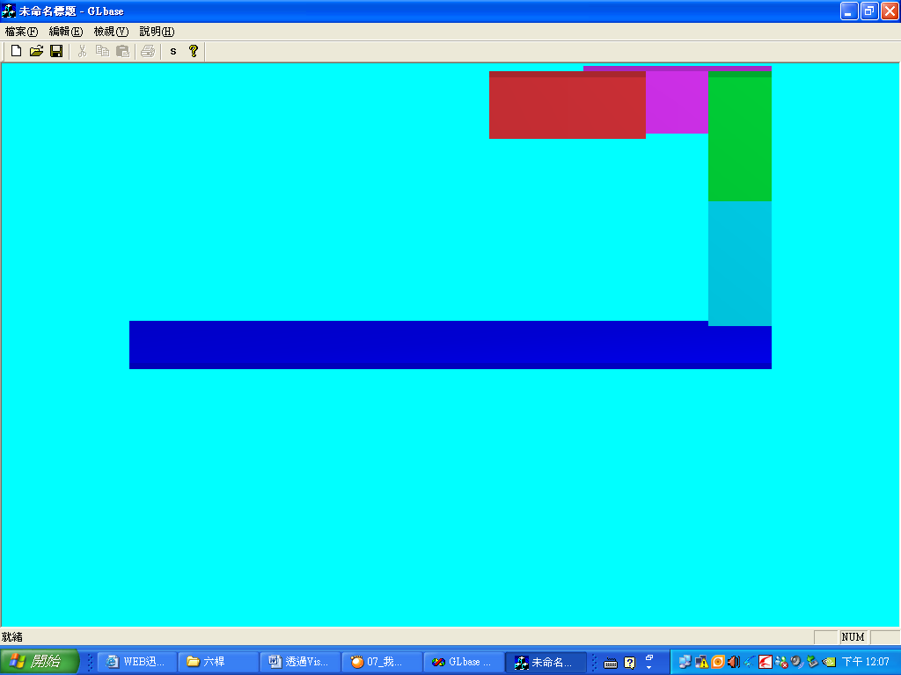
圖五：手臂2建立
2.6手臂2的半圓建立
再建立手臂2後只要在自定的User_Draw加入下列『粗體』程式碼，並執行編譯，即可建立『手臂2的半圓』的部份，其結果如圖六所示：
void CGLbaseView::User_Draw()//第十四步
{
glPushMatrix();///區塊start
{
glTranslatef(0.0f,0.0f,0.0f);
glRotatef(view_x, 1.0f, 0.0f, 0.0f);//視角旋轉角度
glRotatef(view_y, 0.0f, 1.0f, 0.0f);//視角旋轉角度
glRotatef(view_z, 0.0f, 0.0f, 1.0f);//視角旋轉角度
glColor3ub(0.0f,0.0f,130.0f);//設顏色
drawRetc(1024.0f,768.0f,10.0f);//底板
glPushMatrix();///區塊start
{
glColor3ub(0.0f,130.0f,130.0f);
glTranslatef((1024.0f/2.0f-100.0f/2.0f),(768.0f/2.0f-100.0/2.0f),(10.0f/2.0f+200.0f/2.0f));
glTranslatef(trans_x,0.0,0.0);
glTranslatef(0.0,trans_y,0.0);
drawRetc(100.0f,100.0f,200.0f);//主幹1
glRotatef(Rotat1,0.0f,0.0f,1.0f);
glPushMatrix();///區塊start
{
glColor3ub(0.0f,130.0f,30.0f);
glTranslatef(0.0f,0.0f,(200.0f/2.0f)+(200.0f/2.0f));
drawRetc(100.0f,100.0f,200.0f);//主幹2
glPushMatrix();///區塊start
{
glColor3ub(130.0f,30.0f,130.0f);
glTranslatef(100.0f/2.0f-300.0f/2.0f,(100.0f/2.0f+100.0f/2.0f),(200.0f/2.0f)-(100.0f/2.0f));
glTranslatef(300.0f/2.0f-100.0f/2.0f,0.0f,0.0f);
glRotatef(Rotat2,0.0f,1.0f,0.0f);
glTranslatef(-300.0f/2+100.0f/2.0f,0.0f,0.0f);
drawRetc(300.0f,100.0f,100.0f);//手臂1
glPushMatrix();///區塊start
{
glColor3ub(130.0f,30.0f,30.0f);
glTranslatef(-100.0f,0.0f,0.0f);
glRotatef(Rotat3,0.0f,1.0f,0.0f);
glTranslatef(100.0f,0.0f,0.0f);
glTranslatef(-300.0f/2-250.0f/2.0f+100.0f,-100.0f/2.0f-100.0f/2.0f,0.0f);
drawRetc(250.0f,100.0f,100.0f);//手臂2
glPushMatrix();///區塊start
{
glColor3ub(30.0f,130.0f,130.0f);
glTranslatef(-300.0f/2.0f+50.0f/2.0,0.0f,0.0f);
drawCir(50.0f,100.0f,16);//手臂2的半圓
glRotatef(Rotat4,1.0f,0.0f,0.0f);
}
glPopMatrix();///區塊end
}
glPopMatrix();///區塊end
}
glPopMatrix();///區塊end
}
glPopMatrix();///區塊end
}
glPopMatrix();///區塊end
}
glPopMatrix();///區塊end
//////////////////////////////////////////
}
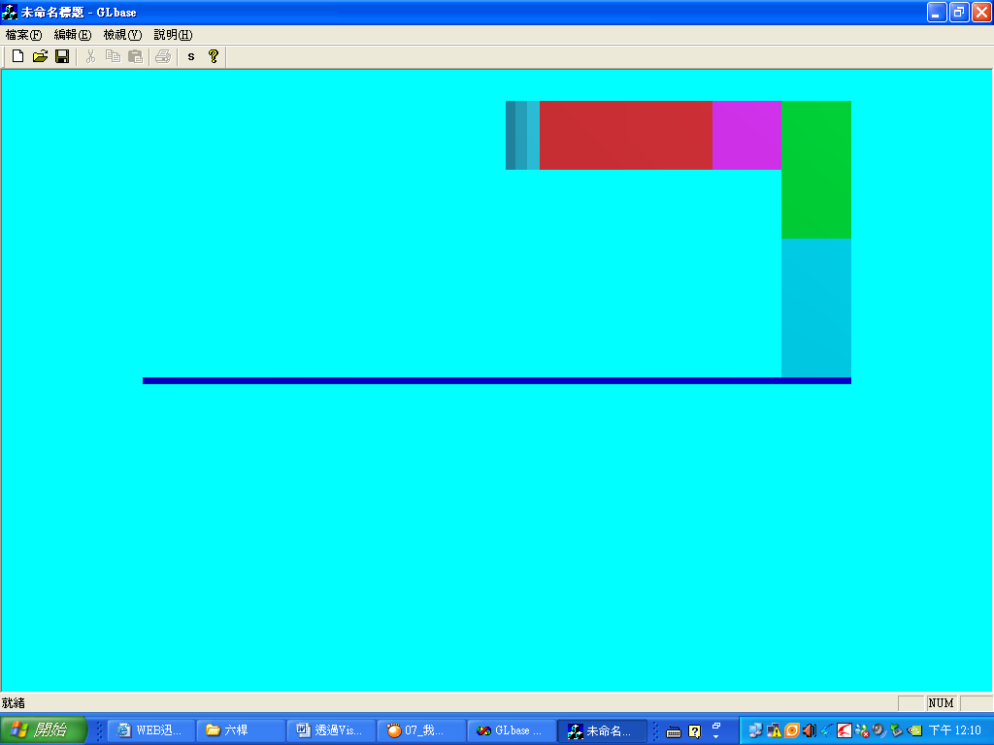
圖六：手臂2的半圓建立
2.7手臂3建立
再建立手臂2的半圓後只要在自定的User_Draw加入下列『粗體』程式碼，並執行編譯，即可建立『手臂3』的部份，其結果如圖七所示：

void CGLbaseView::User_Draw()//第十四步
{
glPushMatrix();///區塊start
{
glTranslatef(0.0f,0.0f,0.0f);
glRotatef(view_x, 1.0f, 0.0f, 0.0f);//視角旋轉角度
glRotatef(view_y, 0.0f, 1.0f, 0.0f);//視角旋轉角度
glRotatef(view_z, 0.0f, 0.0f, 1.0f);//視角旋轉角度
glColor3ub(0.0f,0.0f,130.0f);//設顏色
drawRetc(1024.0f,768.0f,10.0f);//底板
glPushMatrix();///區塊start
{
glColor3ub(0.0f,130.0f,130.0f);
glTranslatef((1024.0f/2.0f-100.0f/2.0f),(768.0f/2.0f-100.0/2.0f),(10.0f/2.0f+200.0f/2.0f));
glTranslatef(trans_x,0.0,0.0);
glTranslatef(0.0,trans_y,0.0);
drawRetc(100.0f,100.0f,200.0f);//主幹1
glRotatef(Rotat1,0.0f,0.0f,1.0f);
glPushMatrix();///區塊start
{
glColor3ub(0.0f,130.0f,30.0f);
glTranslatef(0.0f,0.0f,(200.0f/2.0f)+(200.0f/2.0f));
drawRetc(100.0f,100.0f,200.0f);//主幹2
glPushMatrix();///區塊start
{
glColor3ub(130.0f,30.0f,130.0f);
glTranslatef(100.0f/2.0f-300.0f/2.0f,(100.0f/2.0f+100.0f/2.0f),(200.0f/2.0f)-(100.0f/2.0f));
glTranslatef(300.0f/2.0f-100.0f/2.0f,0.0f,0.0f);
glRotatef(Rotat2,0.0f,1.0f,0.0f);
glTranslatef(-300.0f/2+100.0f/2.0f,0.0f,0.0f);
drawRetc(300.0f,100.0f,100.0f);//手臂1
glPushMatrix();///區塊start
{
glColor3ub(130.0f,30.0f,30.0f);
glTranslatef(-100.0f,0.0f,0.0f);
glRotatef(Rotat3,0.0f,1.0f,0.0f);
glTranslatef(100.0f,0.0f,0.0f);
glTranslatef(-300.0f/2-250.0f/2.0f+100.0f,-100.0f/2.0f-100.0f/2.0f,0.0f);
drawRetc(250.0f,100.0f,100.0f);//手臂2
glPushMatrix();///區塊start
{
glColor3ub(30.0f,130.0f,130.0f);
glTranslatef(-300.0f/2.0f+50.0f/2.0,0.0f,0.0f);
drawCir(50.0f,100.0f,16);//手臂2的半圓
glRotatef(Rotat4,1.0f,0.0f,0.0f);
glPushMatrix();///區塊start
{
glColor3ub(130.0f,130.0f,130.0f);
glRotatef(90.0f,1.0f,0.0f,0.0f);
glTranslatef(-50.0f,0.0f,(150.0f+Trans1)/2.0f);
drawCir(10.0f,150.0f+Trans1,16);//手臂3
}
glPopMatrix();///區塊end
}
glPopMatrix();///區塊end
}
glPopMatrix();///區塊end
}
glPopMatrix();///區塊end
}
glPopMatrix();///區塊end
}
glPopMatrix();///區塊end
}
glPopMatrix();///區塊end
//////////////////////////////////////////
}
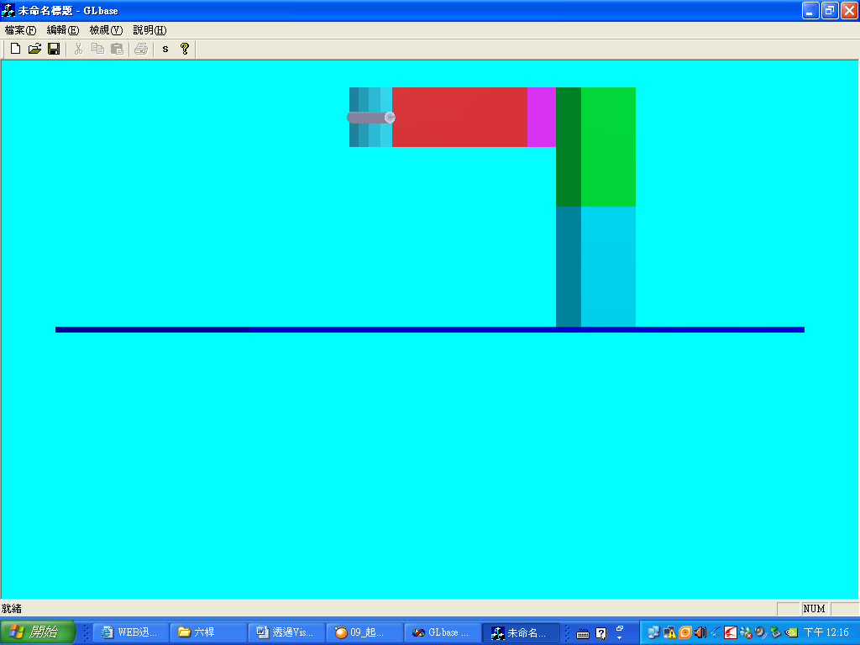
圖七：手臂3建立
2.8手掌建立
最後再建立手臂3後只要在自定的User_Draw加入下列『粗體』程式碼，並執行編譯，即可建立『手掌』的部份，也就完成整個機器手臂的建立，其結果如圖八所示：
void CGLbaseView::User_Draw()//第十四步
{
glPushMatrix();///區塊start
{
glTranslatef(0.0f,0.0f,0.0f);
glRotatef(view_x, 1.0f, 0.0f, 0.0f);//視角旋轉角度
glRotatef(view_y, 0.0f, 1.0f, 0.0f);//視角旋轉角度
glRotatef(view_z, 0.0f, 0.0f, 1.0f);//視角旋轉角度
glColor3ub(0.0f,0.0f,130.0f);//設顏色
drawRetc(1024.0f,768.0f,10.0f);//底板
glPushMatrix();///區塊start
{
glColor3ub(0.0f,130.0f,130.0f);
glTranslatef((1024.0f/2.0f-100.0f/2.0f),(768.0f/2.0f-100.0/2.0f),(10.0f/2.0f+200.0f/2.0f));
glTranslatef(trans_x,0.0,0.0);
glTranslatef(0.0,trans_y,0.0);
drawRetc(100.0f,100.0f,200.0f);//主幹1
glRotatef(Rotat1,0.0f,0.0f,1.0f);
glPushMatrix();///區塊start
{
glColor3ub(0.0f,130.0f,30.0f);
glTranslatef(0.0f,0.0f,(200.0f/2.0f)+(200.0f/2.0f));
drawRetc(100.0f,100.0f,200.0f);//主幹2
glPushMatrix();///區塊start
{
glColor3ub(130.0f,30.0f,130.0f);
glTranslatef(100.0f/2.0f-300.0f/2.0f,(100.0f/2.0f+100.0f/2.0f),(200.0f/2.0f)-(100.0f/2.0f));
glTranslatef(300.0f/2.0f-100.0f/2.0f,0.0f,0.0f);
glRotatef(Rotat2,0.0f,1.0f,0.0f);
glTranslatef(-300.0f/2+100.0f/2.0f,0.0f,0.0f);
drawRetc(300.0f,100.0f,100.0f);//手臂1
glPushMatrix();///區塊start
{
glColor3ub(130.0f,30.0f,30.0f);
glTranslatef(-100.0f,0.0f,0.0f);
glRotatef(Rotat3,0.0f,1.0f,0.0f);
glTranslatef(100.0f,0.0f,0.0f);
glTranslatef(-300.0f/2-250.0f/2.0f+100.0f,-100.0f/2.0f-100.0f/2.0f,0.0f);
drawRetc(250.0f,100.0f,100.0f);//手臂2
glPushMatrix();///區塊start
{
glColor3ub(30.0f,130.0f,130.0f);
glTranslatef(-300.0f/2.0f+50.0f/2.0,0.0f,0.0f);
drawCir(50.0f,100.0f,16);//手臂2的半圓
glRotatef(Rotat4,1.0f,0.0f,0.0f);
glPushMatrix();///區塊start
{
glColor3ub(130.0f,130.0f,130.0f);
glRotatef(90.0f,1.0f,0.0f,0.0f);
glTranslatef(-50.0f,0.0f,(150.0f+Trans1)/2.0f);
drawCir(10.0f,150.0f+Trans1,16);//手臂3
glPushMatrix();///區塊start
{
glTranslatef(0.0f,0.0f,(150.0f+Trans1)/2.0f);
glRotatef(Rotat5,0.0f,0.0f,1.0f);
drawRetc(40.0f,30.0f,3.0f);//手掌
}
glPopMatrix();///區塊end
}
glPopMatrix();///區塊end
}
glPopMatrix();///區塊end
}
glPopMatrix();///區塊end
}
glPopMatrix();///區塊end

}
glPopMatrix();///區塊end
}
glPopMatrix();///區塊end
}
glPopMatrix();///區塊end
//////////////////////////////////////////
}
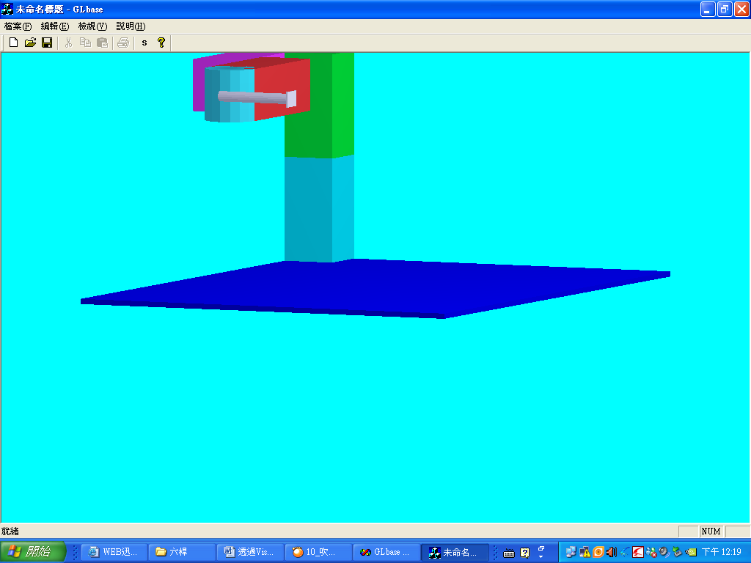
圖八：手掌建立
- 鍵盤控制程式碼介紹
看到這裡，一定有讀者會發現兩個問題，問題一在上面程式碼中除了有建立機器手臂的程式碼以外還有一些不知為何用的程式碼如下所示：
glRotatef(view_x, 1.0f, 0.0f, 0.0f);//視角旋轉角度
glRotatef(view_y, 0.0f, 1.0f, 0.0f);//視角旋轉角度
glRotatef(view_z, 0.0f, 0.0f, 1.0f);//視角旋轉角度
第二個問題是為何作者在上面所顯示的『圖一』到『圖八』每一張圖內機器手臂所顯示的顯示角度均不相同。
沒錯，如果有觀察到這兩個問題的讀者，恭喜你，因為你的問題將得到解答，那是爲了讓我們可以看清楚每個機器手臂的組裝部份，因此作者特別利用MFC內建的鍵盤事件函數，所建立切換Open GL圖的視角功能，其程式碼如下所示：
void CGLbaseView::OnKeyDown(UINT nChar, UINT nRepCnt, UINT nFlags)
{
// TODO: Add your message handler code here and/or call default
switch(nChar)
{
case 65://A,4
view_y+=5.0f;
//MessageBox("A");
break;
case 67://C,3
break;
case 68://D,6
view_y-=5.0f;
//MessageBox("D");
break;
case 69://E,9
view_z+=5.0f;
//MessageBox("E");
break;
case 81://Q,7
view_z-=5.0f;
//MessageBox("Q");
break;
case 83://S,5
view_x=0.0f;
view_y=0.0f;
view_z=0.0f;
break;
case 87://W,8
view_x-=5.0f;
//MessageBox("W");
break;
case 88://X,2
view_x+=5.0f;
//MessageBox("X");
break;
case 90://Z,1
view_z=0.0f;
view_x=-90.0f;
view_y=0.0f;
//MessageBox("Z");
break;
case VK_F5:
Line_Flag = !Line_Flag;
break;
case VK_UP:
trans_x+= 5.0f;
break;
case VK_DOWN:
trans_x -= 5.0f;
break;
case VK_RIGHT:
trans_y += 5.0f;
break;
case VK_LEFT:
trans_y -= 5.0f;
break;
}
Invalidate(true);
CView::OnKeyDown(nChar, nRepCnt, nFlags);
}
其中：
英文鍵：
Q | W | E
A | S | D
Z | X | C
是用來控顯示視角切換用。
上下左右鍵：是用來改變機器手臂的起始位置。
- 簡單UI參數控制
再介紹完控制視角的函數之後，也就進入本文的尾聲，但也是最重要的重頭戲，沒錯就是控制這之機器手臂動作，因此作者再次利用隱藏在機器手臂內的程式碼如下所示：
glRotatef(Rotat1,0.0f,0.0f,1.0f);
glRotatef(Rotat2,0.0f,1.0f,0.0f);
glRotatef(Rotat3,0.0f,1.0f,0.0f);
glRotatef(Rotat4,1.0f,0.0f,0.0f);
glTranslatef(0.0f,0.0f,(150.0f+Trans1)/2.0f);
glRotatef(Rotat5,0.0f,0.0f,1.0f);
並配合上MFC建立的相對應之對話盒與工具列的按鈕完成透過對話盒設定機器手臂的間單UI介面，其程式碼與實現圖如下所示：
void CGLbaseView::Onset()
{
// TODO: Add your command handler code here
///*
CDlg1 dlg1(this);//建立對話盒實體
if(dlg1.DoModal()==IDOK)
{
Rotat1=dlg1.m_v1;
Rotat2=dlg1.m_v2;
Rotat3=dlg1.m_v3;
Rotat4=dlg1.m_v4;
Rotat5=dlg1.m_v5;
Trans1=dlg1.m_v6;

}
Invalidate(true);
//*/
//bar1.show();
}
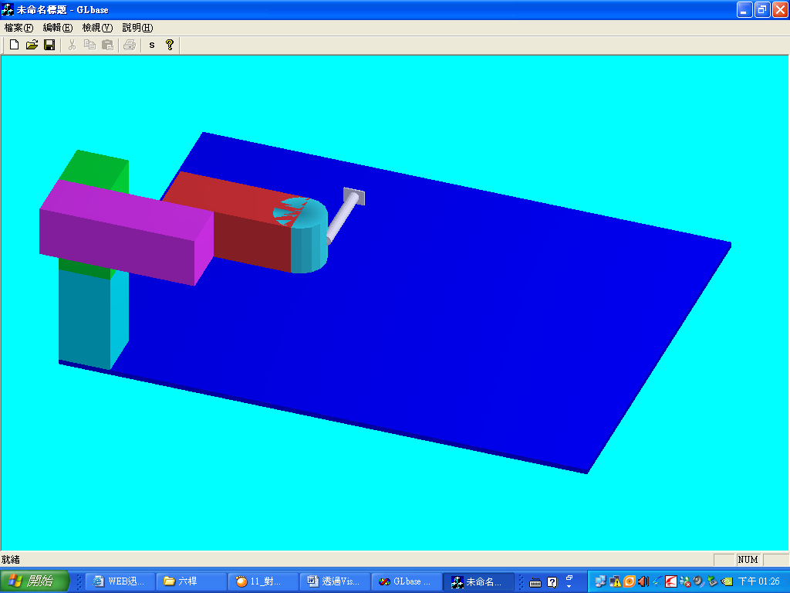
圖九：參數控制預備動作-改變視角
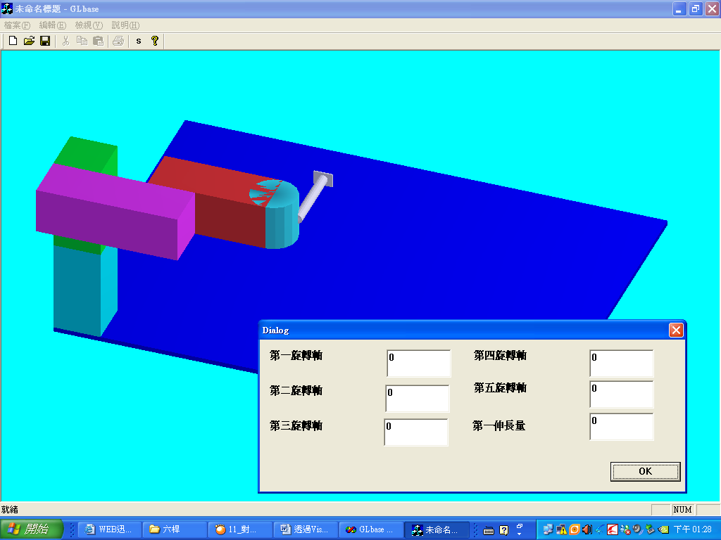
圖十：參數控制預備動作-開啟輸入參數對話盒
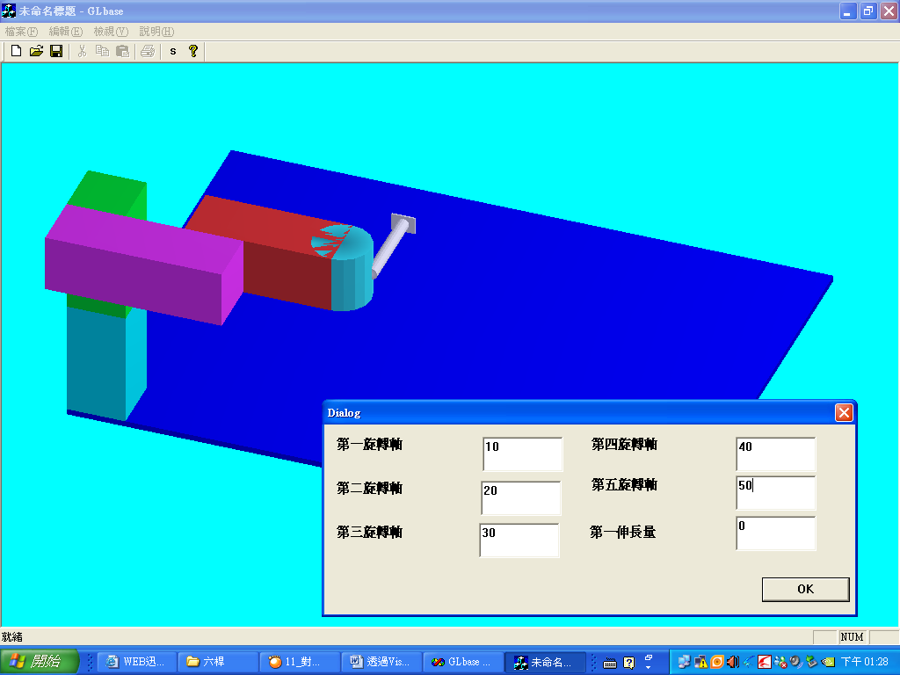
圖十ㄧ：參數控制-輸入參數
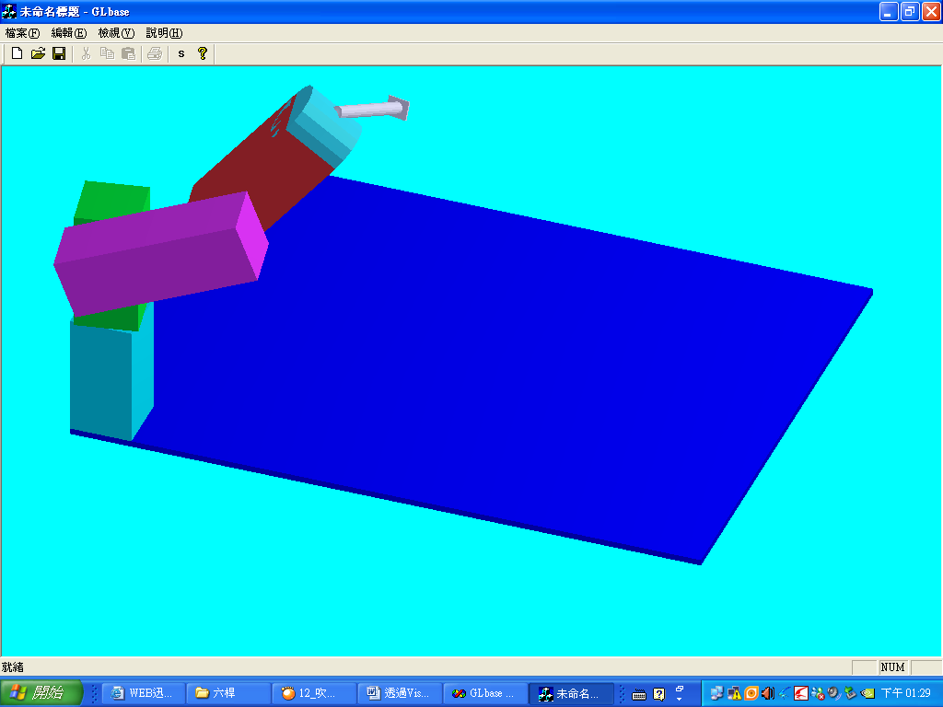
圖十ㄧ：參數控制-執行輸入參數結果
看到這裡，眼尖的讀者可能又發現上面的程式碼有一行是被封鎖起來的，沒錯這是作者留給愛好程式撰寫的讀者的禮物也是功課，因為被封鎖的程式是可以進階操作機器手臂動作的程式碼，如果讀者有興趣可以在實現這兩篇文章之後自行修改測試，一定會發現更有趣的功能，下圖顯示即是修改後的結果，因此各位讀者加油吧。
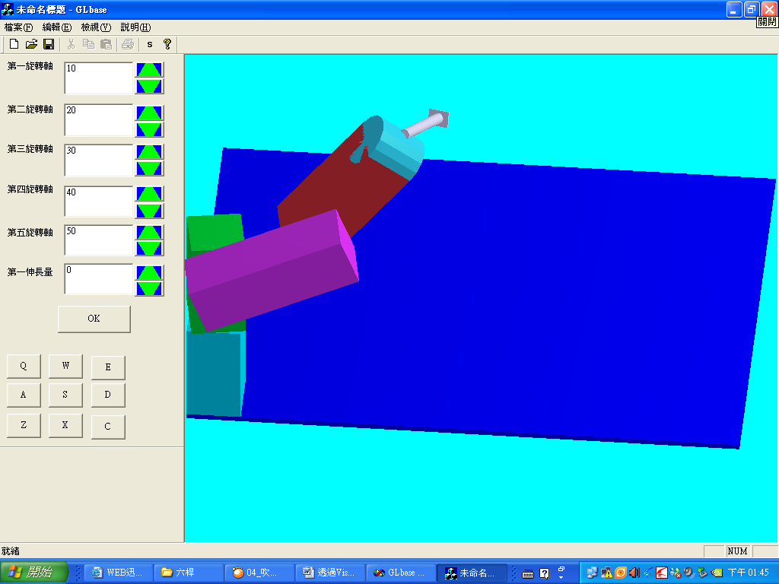
圖十二：進階控制執行輸入參數結果
- 結論：
看完這兩篇文章之後，相信各位讀者應該就可以很清楚如何透過MFC和Open GL整合出自己想要的機械動作模擬程式，但是對於就讀機械系或者是控制系的讀者可能又有疑問，那就是如何讓機器手臂按照自己所想的動作自動工作呢，其實這就牽扯到更深的理論，如運動方程推導或者是相關控制理論等，由於本篇文章的目的只在於拋磚引玉，因此有興趣的讀者可以去參考相關理論的教科書在對城市進行修改；另外由於此篇程式實在過長，因此作者在附錄只附上這一次所介紹相關程式碼，至於其他部分請參考上ㄧ篇文章﹝透過Visual C++配合Open GL實現機器手臂動作模擬(1)﹞，而且作者也將所有程式碼傳至免費的網路空間其下載網址如下：『http://rapidshare.de/files/39600882/___U.rar.html』 以方便各位讀者使用。
參考文獻:
01位元文化編著, 2000,” Windows Me 程式設計入門”,文魁資訊
02韓丹, 2003,”擁抱Visual C++(第四版)” ,儒林圖書公司
03.溫植樺,2006,”使用MFC設計OpenGL”,文魁資訊
04 http://msdn2.microsoft.com/en-us/
05 http://www.codeproject.com
06 http://www.programfan.com
07 http://www.opengl.org/documentation/
08 http://www.cs.utk.edu/~vose/c-stuff/opengl/
附錄：
// glmfc.h//////////////////////////////////////////////////////////////////////////////////////////////////////////////
#ifndef __GLMFC_H__
#define __GLMFC_H__

BOOL CreateRGBPalette(HDC hDC, CPalette * & pPal);

#endif // #ifndef __GLMFC_H__
////////////////////////////////////////////////////////////////////////////////////////////////////////////////////////////
// glmfc.cpp///////////////////////////////////////////////////////////////////////////////////////////////////////////
#include "stdafx.h"
BYTE m_1to8[2] = { 0, 255 };
BYTE m_2to8[4] = { 0, 0x55, 0xaa, 0xff };
BYTE m_3to8[8] = { 0, 0111>>1, 0222>>1, 0333>>1, 0444>>1, 0555>>1, 0666>>1, 0377 };
int m_defaultOverride[13] = { 0, 3, 24, 27, 64, 67, 88, 173, 181, 236, 247, 164, 91 };
PALETTEENTRY m_defaultPalEntry[20] = {
{ 0, 0, 0, 0 }, //0
{ 0x80,0, 0, 0 },
{ 0, 0x80,0, 0 },
{ 0x80,0x80,0, 0 },
{ 0, 0, 0x80,0 },
{ 0x80,0, 0x80,0 },
{ 0, 0x80,0x80,0 },
{ 0xC0,0xC0,0xC0,0 }, //7
{ 192, 220, 192, 0 }, //8
{ 166, 202, 240, 0 },
{ 255, 251, 240, 0 },
{ 160, 160, 164, 0 }, //11
{ 0x80,0x80,0x80,0 }, //12
{ 0xFF,0, 0, 0 },
{ 0, 0xFF,0, 0 },
{ 0xFF,0xFF,0, 0 },
{ 0, 0, 0xFF,0 },
{ 0xFF,0, 0xFF,0 },
{ 0, 0xFF,0xFF,0 },
{ 0xFF,0xFF,0xFF,0 } //19
};
BYTE ComponentFromIndex(int i, UINT nbits, UINT shift)
{
BYTE val;
val = (BYTE) (i >> shift);
switch (nbits) {
case 1:
val &= 0x1;
return m_1to8[val];
case 2:
val &= 0x3;
return m_2to8[val];
case 3:
val &= 0x7;
return m_3to8[val];
}
return 0;
}
BOOL CreateRGBPalette(HDC hDC, CPalette * & pPal)
{
//
// check to see if we need a palette
//
PIXELFORMATDESCRIPTOR pfd;

int n = GetPixelFormat(hDC);
DescribePixelFormat(hDC, n, sizeof(PIXELFORMATDESCRIPTOR), &pfd);
if (FALSE == (pfd.dwFlags & PFD_NEED_PALETTE))
return FALSE;
//
// allocate a log pal and fill it with the color table info
//
TRACE0(_T("creating palette.\r\n"));
LOGPALETTE * pLogPal = (LOGPALETTE *) malloc(sizeof(LOGPALETTE) + 256 * sizeof(PALETTEENTRY));
if (NULL == pLogPal) {
TRACE(_T("out of memory for logpal.\r\n"));
return FALSE;
}
pLogPal->palNumEntries = 256; // table size
pLogPal->palVersion = 0x300; // Windows 3.0
//
// create RGB Palette
//
ASSERT(8 == pfd.cColorBits);
n = 1 << pfd.cColorBits;
for (int i = 0; i < n; ++i) {
pLogPal->palPalEntry[i].peBlue = ComponentFromIndex(i, pfd.cBlueBits, pfd.cBlueShift);
pLogPal->palPalEntry[i].peFlags = 0;
pLogPal->palPalEntry[i].peGreen = ComponentFromIndex(i, pfd.cGreenBits, pfd.cGreenShift);
pLogPal->palPalEntry[i].peRed = ComponentFromIndex(i, pfd.cRedBits, pfd.cRedShift);
}
//
// fix up color table with system colors
//
if ( (2 == pfd.cBlueBits) && (6 == pfd.cBlueShift) &&
(8 == pfd.cColorBits) &&
(3 == pfd.cGreenBits) && (3 == pfd.cGreenShift) &&
(3 == pfd.cRedBits) && (0 == pfd.cRedShift)) {
for (int j = 1 ; j <= 12 ; ++j)
pLogPal->palPalEntry[m_defaultOverride[j]] = m_defaultPalEntry[j];
}
// delete any existing GDI palette
free(pPal);
pPal = new CPalette;
BOOL bResult = pPal->CreatePalette(pLogPal);
free(pLogPal);
return bResult;
}
//OpenGLPara.h////////////////////////////////////////////////////////////////////////////////////////////////////
#ifndef __OPENGLPARA_H__
#define __OPENGLPARA_H__
#include <math.h>
#include <gl/gl.h>
#include <gl/glu.h>
//========= 系統參數設定 =========//

// 旋轉參數
static GLfloat xRot = 0.0f; // X軸視角旋轉參數
static GLfloat yRot = 0.0f; // Y軸視角旋轉參數
static GLfloat zRot = 0.0f; // Z軸視角旋轉參數
bool Line_Flag=false;

static GLfloat nRange = 450.0f;//空間大小

// 燈光參數
static GLfloat ambientLight[] = { 0.8f, 0.8f, 1.0f, 1.0f };
static GLfloat diffuseLight[] = { 0.7f, 0.7f, 0.7f, 1.0f };
static GLfloat specular[] = { 0.7f, 0.7f, 0.7f, 1.0f }; //燈光性質
static GLfloat specref [] = { 0.5f, 0.5f, 0.2f, 1.0f }; //反射性質
static GLfloat lightPos[] = { 1000.0f, 1000.0f, 1000.0f, 1.0f};

// 旗標參數
//static BOOL Line_flag = FALSE;
static BOOL View_lock = TRUE;
int View_flag = 5; // 參數(預設為立體視角)
#define Up_View 1 // 上視圖
#define Front_View 2 // 前視圖
#define Back_View 3 // 後視圖
#define Right_View 4 // 右視圖
#define Left_View 5 // 左視圖
#define Orign_View 6 // 立體圖
#endif
////////////////////////////////////////////////////////////////////////////////////////////////////////////////////////////
//OpenGLFun.h/////////////////////////////////////////////////////////////////////////////////////////////////////
#ifndef __OPENGLFUN_H__
#define __OPENGLFUN_H__
#include <math.h>
#include <gl/gl.h>
#include <gl/glu.h>
#define GL_PI 3.1415f

void ReduceToUnit(float vector[3])
{
float length;

// Calculate the length of the vector
length = (float)sqrt((vector[0]*vector[0]) +
(vector[1]*vector[1]) +
(vector[2]*vector[2]));

// Keep the program from blowing up by providing an exceptable
// value for vectors that may calculated too close to zero.
if(length == 0.0f)
length = 1.0f;

// Dividing each element by the length will result in a
// unit normal vector.
vector[0] /= length;
vector[1] /= length;
vector[2] /= length;
}
void calcNormal(float v[3][3], float out[3])
{
float v1[3],v2[3];
static const int x = 0;
static const int y = 1;
static const int z = 2;

// Calculate two vectors from the three points
v1[x] = v[0][x] - v[1][x];
v1[y] = v[0][y] - v[1][y];
v1[z] = v[0][z] - v[1][z];

v2[x] = v[1][x] - v[2][x];
v2[y] = v[1][y] - v[2][y];
v2[z] = v[1][z] - v[2][z];

// Take the cross product of the two vectors to get
// the normal vector which will be stored in out
out[x] = v1[y]*v2[z] - v1[z]*v2[y];
out[y] = v1[z]*v2[x] - v1[x]*v2[z];
out[z] = v1[x]*v2[y] - v1[y]*v2[x];

// Normalize the vector (shorten length to one)
ReduceToUnit(out);
}

void drawRetc(float W,float L,float H)
{

// if(Line_Side==false)
// {
float normal[3];
glBegin(GL_QUADS);
{
float v[4][3] = {{ W/2, L/2, H/2},
{ -W/2, L/2, H/2},
{ -W/2,-L/2, H/2},
{ W/2,-L/2, H/2}};

// Calculate the normal for the plane
calcNormal(v,normal);
glNormal3fv(normal);
glVertex3fv(v[0]);
glVertex3fv(v[1]);
glVertex3fv(v[2]);
glVertex3fv(v[3]);
}
{
float v[4][3] = {{ W/2, L/2, H/2},
{ W/2,-L/2, H/2},
{ W/2,-L/2,-H/2},
{ W/2, L/2,-H/2}};
calcNormal(v,normal);
glNormal3fv(normal);
glVertex3fv(v[0]);
glVertex3fv(v[1]);
glVertex3fv(v[2]);
glVertex3fv(v[3]);
}
{
float v[4][3] = {{ W/2, L/2, H/2},
{ W/2, L/2,-H/2},
{ -W/2, L/2,-H/2},
{ -W/2, L/2, H/2}};
calcNormal(v,normal);
glNormal3fv(normal);
glVertex3fv(v[0]);
glVertex3fv(v[1]);
glVertex3fv(v[2]);
glVertex3fv(v[3]);
}
{
float v[4][3] = {{-W/2, L/2, H/2},
{ -W/2, L/2,-H/2},
{ -W/2,-L/2,-H/2},
{ -W/2,-L/2, H/2}};
calcNormal(v,normal);
glNormal3fv(normal);
glVertex3fv(v[0]);
glVertex3fv(v[1]);
glVertex3fv(v[2]);
glVertex3fv(v[3]);
}
{
float v[4][3] = {{-W/2,-L/2, H/2},
{ -W/2,-L/2,-H/2},
{ W/2,-L/2,-H/2},
{ W/2,-L/2, H/2}};
calcNormal(v,normal);
glNormal3fv(normal);
glVertex3fv(v[0]);
glVertex3fv(v[1]);
glVertex3fv(v[2]);
glVertex3fv(v[3]);
}
{
float v[4][3] = {{ W/2, L/2,-H/2},
{ W/2,-L/2,-H/2},
{ -W/2,-L/2,-H/2},
{ -W/2, L/2,-H/2}};
calcNormal(v,normal);
glNormal3fv(normal);
glVertex3fv(v[0]);
glVertex3fv(v[1]);
glVertex3fv(v[2]);
glVertex3fv(v[3]);
}
glEnd();
/* }
else
{
// 邊緣線
int i;
glColor3ub(0, 0, 0);
glBegin(GL_LINE_STRIP);
{
float v[4][3] = {{ W/2, L/2, H/2},
{ -W/2, L/2, H/2},
{ -W/2,-L/2, H/2},
{ W/2,-L/2, H/2}};
for(i=0; i<5; i++)
glVertex3fv(v[i%4]);
}
glEnd();
glBegin(GL_LINE_STRIP);
{
float v[4][3] = {{ W/2, L/2,-H/2},
{ -W/2, L/2,-H/2},
{ -W/2,-L/2,-H/2},
{ W/2,-L/2,-H/2}};
for(i=0; i<5; i++)
glVertex3fv(v[i%4]);
}
glEnd();
glBegin(GL_LINE_STRIP);
{
float v[4][3] = {{-W/2, L/2, H/2},
{ -W/2,-L/2, H/2},
{ -W/2,-L/2,-H/2},
{ -W/2, L/2,-H/2}};
for(i=0; i<5; i++)
glVertex3fv(v[i%4]);
}
glEnd();
glBegin(GL_LINE_STRIP);
{
float v[4][3] = {{ W/2, L/2, H/2},
{ W/2,-L/2, H/2},
{ W/2,-L/2,-H/2},
{ W/2, L/2,-H/2}};
for(i=0; i<5; i++)
glVertex3fv(v[i%4]);
}
glEnd();
// 邊緣線(完)
}
*/
}

void drawCir(float radius, float L, int segment)
{
float angle[2];
float normal[3];

// if(Line_Side==false)
// {
glBegin(GL_QUADS);
{
for(angle[0]=0.0f, angle[1]=0.0f; angle[0]< (2.0f*GL_PI); angle[0]+=((2.0f*GL_PI)/segment))
{
float r[4][3] = {{radius*(float)cos(angle[1]), radius*(float)sin(angle[1]), L/2},
{ radius*(float)cos(angle[1]), radius*(float)sin(angle[1]),-L/2},
{ radius*(float)cos(angle[0]), radius*(float)sin(angle[0]),-L/2},
{ radius*(float)cos(angle[0]), radius*(float)sin(angle[0]), L/2}};
calcNormal(r,normal);
glNormal3fv(normal);
glVertex3fv(r[0]);
glVertex3fv(r[1]);
glVertex3fv(r[2]);
glVertex3fv(r[3]);
angle[1]=angle[0];
}
}
glEnd();

glBegin(GL_TRIANGLE_FAN);
{
glVertex3f(0.0f, 0.0f, L/2);
for (angle[1]=0.0f, angle[0]=0.0f; angle[1]<=(2.0f*GL_PI); angle[0]+=((2.0f*GL_PI)/segment))
{
float x=radius*(float)cos(angle[0]);
float y=radius*(float)sin(angle[0]);

float v[3][3] = {{0.0f , 0.0f , L/2},
{ radius*(float)cos(angle[1]), radius*(float)sin(angle[1]), L/2},
{ radius*(float)cos(angle[0]), radius*(float)sin(angle[0]), L/2}};
calcNormal(v,normal);
glNormal3fv(normal);
glVertex3f(x, y, L/2);
angle[1]=angle[0];
}
}
glEnd();

glBegin(GL_TRIANGLE_FAN);
{
glVertex3f(0.0f, 0.0f,-L/2);
for (angle[1]=0.0f, angle[0]=0.0f; angle[1]<= (2.0f*GL_PI); angle[0]+=((2.0f*GL_PI)/segment))
{
float x=radius*(float)cos(angle[0]);
float y=radius*(float)sin(angle[0]);
float v[3][3] = {{0.0f , 0.0f ,-L/2},
{ radius*(float)cos(angle[0]), radius*(float)sin(angle[0]),-L/2},
{ radius*(float)cos(angle[1]), radius*(float)sin(angle[1]),-L/2}};
calcNormal(v,normal);
glNormal3fv(normal);
glVertex3f(x, y,-L/2);
angle[1]=angle[0];
}
}
glEnd();
/* }
else
{
// 線條邊緣

float start_point[16][3];
float end_point[16][3];
int k=0;
glColor3ub(0, 0, 0);
glBegin(GL_LINE_STRIP);
{
float angle,x,y,z;
for (angle=0.0f; angle <= (2.0f*GL_PI); angle+=((2.0f*GL_PI)/segment))
{
x = radius*(float)cos(angle);
y = radius*(float)sin(angle);
start_point[k][0]=x;
start_point[k][1]=y;
z = L/2;
start_point[k][2]=z;
k+=1;
glVertex3f(x, y, z);
}
}
glEnd();
k=0;
glBegin(GL_LINE_STRIP);
{
float angle,x,y,z;
for (angle=0.0f; angle <= (2.0f*GL_PI); angle+=((2.0f*GL_PI)/segment))
{
x = radius*(float)cos(angle);
y = radius*(float)sin(angle);
end_point[k][0]=x;
end_point[k][1]=y;
z = -L/2;
end_point[k][2]=z;
k+=1;
glVertex3f(x, y, z);
}
}
glEnd();
for(int i=0;i<16;i++)
{
glBegin(GL_LINES);
{
glVertex3f(start_point[i][0], start_point[i][1], start_point[i][2]);
glVertex3f(end_point[i][0], end_point[i][1], end_point[i][2]);
}
glEnd();
}
}
*/
}
void drawtriangle(float W,float L,float H)
{
// if(Line_Side==false)
// {
static float normal[3];
glBegin(GL_QUADS);
{
float v[4][3] = {{ W/2, L/2, -H/2},
{ -W/2, L/2, H/2},
{ -W/2,-L/2, H/2},
{ W/2,-L/2, -H/2}};

// Calculate the normal for the plane
calcNormal(v,normal);
glNormal3fv(normal);
glVertex3fv(v[0]);
glVertex3fv(v[1]);
glVertex3fv(v[2]);
glVertex3fv(v[3]);
}
{
float v[3][3] = {{ W/2, L/2, -H/2},
{ -W/2,L/2, -H/2},
{ -W/2,L/2,H/2}};
calcNormal(v,normal);
glNormal3fv(normal);
glVertex3fv(v[0]);
glVertex3fv(v[1]);
glVertex3fv(v[2]);
glVertex3fv(v[3]);
}
{
float v[4][3] = {{ -W/2, L/2, H/2},
{ -W/2, L/2,-H/2},
{ -W/2, -L/2,-H/2},
{ -W/2, -L/2, H/2}};
calcNormal(v,normal);
glNormal3fv(normal);
glVertex3fv(v[0]);
glVertex3fv(v[1]);
glVertex3fv(v[2]);
glVertex3fv(v[3]);
}
{
float v[3][3] = {{-W/2, -L/2, H/2},
{ -W/2, -L/2,-H/2},
{ W/2,-L/2,-H/2}};
calcNormal(v,normal);
glNormal3fv(normal);
glVertex3fv(v[0]);
glVertex3fv(v[1]);
glVertex3fv(v[2]);
glVertex3fv(v[3]);
}
{
float v[4][3] = {{ W/2, L/2, -H/2},
{ W/2, -L/2,-H/2},
{ -W/2, -L/2,-H/2},
{ -W/2, L/2, -H/2}};
calcNormal(v,normal);
glNormal3fv(normal);
glVertex3fv(v[0]);
glVertex3fv(v[1]);
glVertex3fv(v[2]);
glVertex3fv(v[3]);
}

glEnd();

/* }
else
{
// 邊緣線
int i;
glColor3ub(0, 0, 0);
glBegin(GL_LINE_STRIP);
{
float v[4][3] = {{ W/2, L/2, -H/2},
{ -W/2, L/2, H/2},
{ -W/2,-L/2, H/2},
{ W/2,-L/2, -H/2}};
for(i=0; i<5; i++)
glVertex3fv(v[i%4]);
}
glEnd();
glBegin(GL_LINE_STRIP);
{
float v[4][3] = {{ -W/2, L/2, H/2},
{ -W/2, L/2,-H/2},
{ -W/2, -L/2,-H/2},
{ -W/2, -L/2, H/2}};
for(i=0; i<5; i++)
glVertex3fv(v[i%4]);
}
glEnd();
glBegin(GL_LINE_STRIP);
{
float v[4][3] = {{ W/2, L/2, -H/2},
{ -W/2,L/2, -H/2},
{ -W/2, -L/2,-H/2},
{ W/2,-L/2,-H/2}};
for(i=0; i<5; i++)
glVertex3fv(v[i%4]);
}
glEnd();

// 邊緣線(完)
}
*/
}

void drawtriangle_1(float W,float L,float H)
{
// if(Line_Side==false)
// {
static float normal[3];
glBegin(GL_QUADS);
{
float v[4][3] = {{ W/2, -L/2, H/2},
{ W/2, L/2, H/2},
{ -W/2,L/2, -H/2},
{ -W/2,-L/2, -H/2}};

// Calculate the normal for the plane
calcNormal(v,normal);
glNormal3fv(normal);
glVertex3fv(v[0]);
glVertex3fv(v[1]);
glVertex3fv(v[2]);
glVertex3fv(v[3]);
}
{
float v[3][3] = {{ W/2, L/2, H/2},
{ W/2,L/2, -H/2},
{ -W/2,L/2,-H/2}};
calcNormal(v,normal);
glNormal3fv(normal);
glVertex3fv(v[0]);
glVertex3fv(v[1]);
glVertex3fv(v[2]);
glVertex3fv(v[3]);
}
{
float v[4][3] = {{ W/2, L/2, H/2},
{ W/2, -L/2,H/2},
{ W/2, -L/2,-H/2},
{ W/2, L/2, -H/2}};
calcNormal(v,normal);
glNormal3fv(normal);
glVertex3fv(v[0]);
glVertex3fv(v[1]);
glVertex3fv(v[2]);
glVertex3fv(v[3]);
}
{
float v[3][3] = {{W/2, -L/2, H/2},
{ -W/2,-L/2,-H/2},
{ W/2, -L/2,-H/2}};
calcNormal(v,normal);
glNormal3fv(normal);
glVertex3fv(v[0]);
glVertex3fv(v[1]);
glVertex3fv(v[2]);
glVertex3fv(v[3]);
}
{
float v[4][3] = {{ -W/2, L/2, -H/2},
{ W/2, L/2,-H/2},
{ W/2, -L/2,-H/2},
{ -W/2, -L/2, -H/2}};
calcNormal(v,normal);
glNormal3fv(normal);
glVertex3fv(v[0]);
glVertex3fv(v[1]);
glVertex3fv(v[2]);
glVertex3fv(v[3]);
}

glEnd();

/* }
else
{
// 邊緣線
int i;
glColor3ub(0, 0, 0);
glBegin(GL_LINE_STRIP);
{
float v[4][3] = {{ W/2, -L/2, H/2},
{ W/2, L/2, H/2},
{ -W/2,L/2, -H/2},
{ -W/2,-L/2, -H/2}};
for(i=0; i<5; i++)
glVertex3fv(v[i%4]);
}
glEnd();
glBegin(GL_LINE_STRIP);
{
float v[4][3] = {{ W/2, -L/2, H/2},
{ W/2, L/2, H/2},
{ W/2, L/2,-H/2},
{ W/2, -L/2,-H/2}};
for(i=0; i<5; i++)
glVertex3fv(v[i%4]);
}
glEnd();
glBegin(GL_LINE_STRIP);
{
float v[4][3] = {{ W/2, L/2,-H/2},
{ -W/2,L/2, -H/2},
{ -W/2,-L/2, -H/2},
{ W/2, -L/2,-H/2}};
for(i=0; i<5; i++)
glVertex3fv(v[i%4]);
}
glEnd();

// 邊緣線(完)
}
*/
}

void drawladder(float U,float L,float H,float W)

{
// if(Line_Side==false)
// {
static float normal[3];
glBegin(GL_QUADS);
{
float v[4][3] = {{ U/2, W/2, H/2},
{ -U/2, W/2, H/2},
{ -U/2,-W/2, H/2},
{ U/2,-W/2, H/2}};
// Calculate the normal for the plane
calcNormal(v,normal);
glNormal3fv(normal);
glVertex3fv(v[0]);
glVertex3fv(v[1]);
glVertex3fv(v[2]);
glVertex3fv(v[3]);
}
{
float v[4][3] = {{ U/2, -W/2, H/2},
{ -U/2,-W/2, H/2},
{ -L/2,-W/2,-H/2},
{ L/2,-W/2,-H/2}};
calcNormal(v,normal);
glNormal3fv(normal);
glVertex3fv(v[0]);
glVertex3fv(v[1]);
glVertex3fv(v[2]);
glVertex3fv(v[3]);
}
{
float v[4][3] = {{ U/2, W/2, H/2},
{ U/2, -W/2,H/2},
{ L/2, -W/2,-H/2},
{ L/2, W/2, -H/2}};
calcNormal(v,normal);
glNormal3fv(normal);
glVertex3fv(v[0]);
glVertex3fv(v[1]);
glVertex3fv(v[2]);
glVertex3fv(v[3]);
}
{
float v[4][3] = {{U/2, W/2, H/2},
{ -U/2, W/2,H/2},
{ -L/2, W/2,-H/2},
{ L/2, W/2,-H/2}};
calcNormal(v,normal);
glNormal3fv(normal);
glVertex3fv(v[0]);
glVertex3fv(v[1]);
glVertex3fv(v[2]);
glVertex3fv(v[3]);
}
{
float v[4][3] = {{-U/2,W/2, H/2},
{ -U/2,-W/2,H/2},
{ -L/2,-W/2,-H/2},
{ -L/2,W/2,-H/2}};
calcNormal(v,normal);
glNormal3fv(normal);
glVertex3fv(v[0]);
glVertex3fv(v[1]);
glVertex3fv(v[2]);
glVertex3fv(v[3]);
}
{
float v[4][3] = {{ L/2, W/2,-H/2},
{ -L/2, W/2,-H/2},
{ -L/2,-W/2,-H/2},
{ L/2,-W/2,-H/2}};
calcNormal(v,normal);
glNormal3fv(normal);
glVertex3fv(v[0]);
glVertex3fv(v[1]);
glVertex3fv(v[2]);
glVertex3fv(v[3]);
}
glEnd();

// }
// else
// {
// 邊緣線
/* int i;
glColor3ub(0, 0, 0);
glBegin(GL_LINE_STRIP);
{
float v[4][3] = {{ U/2, W/2, H/2},
{ -U/2, W/2, H/2},
{ -U/2,-W/2, H/2},
{ U/2,-W/2, H/2}};
for(i=0; i<5; i++)
glVertex3fv(v[i%4]);
}
glEnd();
glBegin(GL_LINE_STRIP);
{
float v[4][3] = {{ L/2, W/2,-H/2},
{ -L/2, W/2,-H/2},
{ -L/2,-W/2,-H/2},
{ L/2,-W/2,-H/2}};
for(i=0; i<5; i++)
glVertex3fv(v[i%4]);
}
glEnd();
glBegin(GL_LINE_STRIP);
{
float v[4][3] = {{-U/2,W/2, H/2},
{ -U/2,-W/2,H/2},
{ -L/2,-W/2,-H/2},
{ -L/2,W/2,-H/2}};
for(i=0; i<5; i++)
glVertex3fv(v[i%4]);
}
glEnd();
glBegin(GL_LINE_STRIP);
{
float v[4][3] = {{ U/2, W/2, H/2},
{ U/2, -W/2,H/2},
{ L/2, -W/2,-H/2},
{ L/2, W/2, -H/2}};
for(i=0; i<5; i++)
glVertex3fv(v[i%4]);
}
glEnd();
// 邊緣線(完)
}
*/
}

#endif
//////////////////////////////////////////////////////////////////////////////////////////////////////////////////////////////GLbaseView.h/////////////////////////////////////////////////////////////////////////////////////////////////////

#if !defined(AFX_GLBASEVIEW_H__CA6432EC_29B3_11DA_B776_0040F43A9B72__INCLUDED_)
#define AFX_GLBASEVIEW_H__CA6432EC_29B3_11DA_B776_0040F43A9B72__INCLUDED_

#if _MSC_VER > 1000
#pragma once
#endif // _MSC_VER > 1000

#include "Bar.h"
class CGLbaseView : public CView
{
protected: // create from serialization only
CGLbaseView();
DECLARE_DYNCREATE(CGLbaseView)

// Attributes
public:
CGLbaseDoc* GetDocument();
CBar bar1;
CClientDC *dc;//第二步
HGLRC m_hrc; ///< OpenGL rendering context
CPalette * m_pPal; ///< palette
void opengl_Initial();//第八步
void User_Draw();//第十三步
// Operations
public:

// Overrides
// ClassWizard generated virtual function overrides
//{{AFX_VIRTUAL(CGLbaseView)
public:
virtual void OnDraw(CDC* pDC); // overridden to draw this view
virtual BOOL PreCreateWindow(CREATESTRUCT& cs);
protected:
//}}AFX_VIRTUAL

// Implementation
public:
virtual ~CGLbaseView();
#ifdef _DEBUG
virtual void AssertValid() const;
virtual void Dump(CDumpContext& dc) const;
#endif

protected:

// Generated message map functions
protected:
//{{AFX_MSG(CGLbaseView)
afx_msg int OnCreate(LPCREATESTRUCT lpCreateStruct);
afx_msg void OnSize(UINT nType, int cx, int cy);
afx_msg BOOL OnEraseBkgnd(CDC* pDC);
afx_msg void OnKeyDown(UINT nChar, UINT nRepCnt, UINT nFlags);
afx_msg void Onset();
afx_msg void OnButton1();
afx_msg void OnA();
afx_msg void OnC();
afx_msg void OnD();
afx_msg void OnE();
afx_msg void OnQ();
afx_msg void OnS();
afx_msg void OnW();
afx_msg void OnX();
afx_msg void OnZ();
afx_msg void OnUp1();
afx_msg void OnUp2();
afx_msg void OnUp3();
afx_msg void OnUp4();
afx_msg void OnUp5();
afx_msg void OnUp6();
afx_msg void OnDown1();
afx_msg void OnDown2();
afx_msg void OnDown3();
afx_msg void OnDown4();
afx_msg void OnDown5();
afx_msg void OnDown6();
//}}AFX_MSG
DECLARE_MESSAGE_MAP()
};

#ifndef _DEBUG // debug version in GLbaseView.cpp
inline CGLbaseDoc* CGLbaseView::GetDocument()
{ return (CGLbaseDoc*)m_pDocument; }
#endif

/////////////////////////////////////////////////////////////////////////////

//{{AFX_INSERT_LOCATION}}
// Microsoft Visual C++ will insert additional declarations immediately before the previous line.

#endif // !defined(AFX_GLBASEVIEW_H__CA6432EC_29B3_11DA_B776_0040F43A9B72__INCLUDED_)
////////////////////////////////////////////////////////////////////////////////////////////////////////////////////////////
// GLbaseView.cpp/////////////////////////////////////////////////////////////////////////////////////////////////
#include "stdafx.h"
#include "GLbase.h"
#include <gl/glut.h>//第三步
#include "glmfc.h"//第三步
#include "GLbaseDoc.h"
#include "GLbaseView.h"
#include "OpenGLFun.h"//第六步
#include "OpenGLPara.h"
#include "Dlg1.h"
#ifdef _DEBUG
#define new DEBUG_NEW
#undef THIS_FILE
static char THIS_FILE[] = __FILE__;
#endif
float view_x,view_y,view_z;
float trans_x,trans_y;
float Rotat1,Rotat2,Rotat3,Rotat4,Rotat5;
float Trans1;
/////////////////////////////////////////////////////////////////////////////
// CGLbaseView

IMPLEMENT_DYNCREATE(CGLbaseView, CView)

BEGIN_MESSAGE_MAP(CGLbaseView, CView)
//{{AFX_MSG_MAP(CGLbaseView)
ON_WM_CREATE()
ON_WM_SIZE()
ON_WM_ERASEBKGND()
ON_WM_KEYDOWN()
ON_COMMAND(ID_set, Onset)
ON_BN_CLICKED(IDC_BUTTON1, OnButton1)
ON_BN_CLICKED(IDC_A, OnA)
ON_BN_CLICKED(IDC_C, OnC)
ON_BN_CLICKED(IDC_D, OnD)
ON_BN_CLICKED(IDC_E, OnE)
ON_BN_CLICKED(IDC_Q, OnQ)
ON_BN_CLICKED(IDC_S, OnS)
ON_BN_CLICKED(IDC_W, OnW)
ON_BN_CLICKED(IDC_X, OnX)
ON_BN_CLICKED(IDC_Z, OnZ)
ON_BN_CLICKED(IDC_UP1, OnUp1)
ON_BN_CLICKED(IDC_UP2, OnUp2)
ON_BN_CLICKED(IDC_UP3, OnUp3)
ON_BN_CLICKED(IDC_UP4, OnUp4)
ON_BN_CLICKED(IDC_UP5, OnUp5)
ON_BN_CLICKED(IDC_UP6, OnUp6)
ON_BN_CLICKED(IDC_Down1, OnDown1)
ON_BN_CLICKED(IDC_Down2, OnDown2)
ON_BN_CLICKED(IDC_Down3, OnDown3)
ON_BN_CLICKED(IDC_Down4, OnDown4)
ON_BN_CLICKED(IDC_Down5, OnDown5)
ON_BN_CLICKED(IDC_Down6, OnDown6)
//}}AFX_MSG_MAP
END_MESSAGE_MAP()

/////////////////////////////////////////////////////////////////////////////
// CGLbaseView construction/destruction

CGLbaseView::CGLbaseView()
{
// TODO: add construction code here

}

CGLbaseView::~CGLbaseView()
{
}

BOOL CGLbaseView::PreCreateWindow(CREATESTRUCT& cs)
{
// TODO: Modify the Window class or styles here by modifying
// the CREATESTRUCT cs

return CView::PreCreateWindow(cs);
}

/////////////////////////////////////////////////////////////////////////////
// CGLbaseView drawing

void CGLbaseView::OnDraw(CDC* pDC)
{
m_pPal = NULL;//第十步
CGLbaseDoc* pDoc = GetDocument();
ASSERT_VALID(pDoc);
////////////////////////////////////////第七步
CPalette * ppalOld = NULL;
if (m_pPal) {
ppalOld = pDC->SelectPalette(m_pPal, 0);
pDC->RealizePalette();
}
BOOL bResult = wglMakeCurrent(pDC->m_hDC, m_hrc);
if (FALSE == bResult)
TRACE(_T("wglMakeCurrent() failed %x.\r\n"), ::GetLastError());

opengl_Initial();

static GLfloat ambientLight[] = { 1.0f, 1.0f, 1.0f, 1.0f };
static GLfloat diffuseLight[] = { 0.7f, 0.7f, 0.7f, 1.0f };
static GLfloat specular[] = { 0.7f, 0.7f, 0.7f, 1.0f }; //燈光性質
static GLfloat specref [] = { 0.5f, 0.5f, 0.2f, 1.0f }; //反射性質
static float normal[3];//設定法向量

// Clear the window with current clearing color
glClear(GL_COLOR_BUFFER_BIT | GL_DEPTH_BUFFER_BIT);//清除畫面的動作
if(Line_Flag)
glPolygonMode(GL_FRONT_AND_BACK, GL_LINE);//會產生多邊形的外圍輪廓
else
glPolygonMode(GL_FRONT_AND_BACK, GL_FILL);//會產生填滿的多邊形
///////////////////////////////////////////
User_Draw();//第十五步
////////////////////////第十一步
glFlush();
SwapBuffers(pDC->m_hDC);

if (ppalOld)
pDC->SelectPalette(ppalOld, 0);

wglMakeCurrent(NULL, NULL);
}

/////////////////////////////////////////////////////////////////////////////
// CGLbaseView diagnostics

#ifdef _DEBUG
void CGLbaseView::AssertValid() const
{
CView::AssertValid();
}

void CGLbaseView::Dump(CDumpContext& dc) const
{
CView::Dump(dc);
}

CGLbaseDoc* CGLbaseView::GetDocument() // non-debug version is inline
{
ASSERT(m_pDocument->IsKindOf(RUNTIME_CLASS(CGLbaseDoc)));
return (CGLbaseDoc*)m_pDocument;
}
#endif //_DEBUG

/////////////////////////////////////////////////////////////////////////////
// CGLbaseView message handlers

int CGLbaseView::OnCreate(LPCREATESTRUCT lpCreateStruct)
{
if (CView::OnCreate(lpCreateStruct) == -1)
return -1;

///////////////////////////////////////////第四步
dc = new CClientDC (this);
PIXELFORMATDESCRIPTOR pfd;

memset(&pfd, 0, sizeof(PIXELFORMATDESCRIPTOR));
pfd.cColorBits = 24;
pfd.cDepthBits = 32;
pfd.dwFlags = PFD_DOUBLEBUFFER | PFD_DRAW_TO_WINDOW | PFD_SUPPORT_OPENGL;
pfd.iLayerType = PFD_MAIN_PLANE;
pfd.iPixelType = PFD_TYPE_RGBA;
pfd.nSize = sizeof(PIXELFORMATDESCRIPTOR);
pfd.nVersion = 1;

int nPixelFormat = ChoosePixelFormat(dc->m_hDC, &pfd);
if (0 == nPixelFormat) {
TRACE(_T("ChoosePixelFormat() failed %d.\r\n"), GetLastError());
return -1;
}
TRACE(_T("pixel format %d.\r\n"), nPixelFormat);

BOOL bResult = SetPixelFormat(dc->m_hDC, nPixelFormat, &pfd);
if (FALSE == bResult) {
TRACE(_T("SetPixelFormat() failed %d.\r\n"),GetLastError());
return -1;
}

//
// create a rendering context
//
m_hrc = wglCreateContext(dc->m_hDC);
if (NULL == m_hrc) {
TRACE(_T("wglCreateContext() failed %x.\r\n"), GetLastError());
return -1;
}

//
// create the palette
//
CreateRGBPalette(dc->m_hDC, m_pPal);
return 0;
}

void CGLbaseView::OnSize(UINT nType, int cx, int cy)
{
CView::OnSize(nType, cx, cy);

///////////////////////////////////////////第五步
if ((cx <= 0) || (cy <= 0))
return;

BOOL bResult = wglMakeCurrent(dc->m_hDC, m_hrc);
if (FALSE == bResult) {
TRACE(_T("wglMakeCurrent() failed %x.\r\n"), GetLastError());
return;
}

int w = cx;
int h = cy;
// Prevent a divide by zero
if(h == 0)
h = 1;

// Set Viewport to window dimensions
glViewport(0, 0, w, h);//設定視窗中可以讓Open GL繪圖的部分

// Reset coordinate system
glMatrixMode(GL_PROJECTION);
glLoadIdentity();

// Establish clipping volume (left, right, bottom, top, near, far)
if (w <= h)
glOrtho (-nRange, nRange, -nRange*h/w, nRange*h/w, -nRange*2, nRange*2);
else
glOrtho (-nRange*w/h, nRange*w/h, -nRange, nRange, -nRange*2, nRange*2);

glMatrixMode(GL_MODELVIEW);
glLoadIdentity();
glLightfv(GL_LIGHT0, GL_POSITION, lightPos);
wglMakeCurrent(NULL, NULL);

}
void CGLbaseView::opengl_Initial()//第九步
{
//open gl初始值設定
glEnable(GL_DEPTH_TEST); // Hidden surface removal
glFrontFace(GL_CCW); // Counter clock-wise polygons face out
glDisable(GL_CULL_FACE); // Do not calculate inside of jet
glShadeModel(GL_SMOOTH);

glEnable(GL_LIGHTING);
glLightfv(GL_LIGHT0,GL_AMBIENT,ambientLight);
glLightfv(GL_LIGHT0,GL_DIFFUSE,diffuseLight);
glLightfv(GL_LIGHT0,GL_SPECULAR,specular);
glEnable(GL_LIGHT0);

glColorMaterial(GL_FRONT, GL_AMBIENT_AND_DIFFUSE);
glEnable(GL_COLOR_MATERIAL);

glMaterialfv(GL_FRONT, GL_SPECULAR, specref);//將多邊形設為具有反射性質
glMateriali(GL_FRONT, GL_SHININESS, 128);//設定反射性質的亮度
glClearColor(0.0f, 100.0f, 150.0f, 1.0f );//設定桌布顏色
glClear(GL_COLOR_BUFFER_BIT | GL_DEPTH_BUFFER_BIT);//清除螢幕動作

}

BOOL CGLbaseView::OnEraseBkgnd(CDC* pDC)
{
// TODO: Add your message handler code here and/or call default

return TRUE;//第十二步
}

void CGLbaseView::OnKeyDown(UINT nChar, UINT nRepCnt, UINT nFlags)
{
// TODO: Add your message handler code here and/or call default
switch(nChar)
{
case 65://A,4
view_y+=5.0f;
//MessageBox("A");
break;
case 67://C,3
break;
case 68://D,6
view_y-=5.0f;
//MessageBox("D");
break;
case 69://E,9
view_z+=5.0f;
//MessageBox("E");
break;
case 81://Q,7
view_z-=5.0f;
//MessageBox("Q");
break;
case 83://S,5
view_x=0.0f;
view_y=0.0f;
view_z=0.0f;
break;
case 87://W,8
view_x-=5.0f;
//MessageBox("W");
break;
case 88://X,2
view_x+=5.0f;
//MessageBox("X");
break;
case 90://Z,1
view_z=0.0f;
view_x=-90.0f;
view_y=0.0f;
//MessageBox("Z");
break;
case VK_F5:
Line_Flag = !Line_Flag;
break;
case VK_UP:
trans_x+= 5.0f;
break;
case VK_DOWN:
trans_x -= 5.0f;
break;
case VK_RIGHT:
trans_y += 5.0f;
break;
case VK_LEFT:
trans_y -= 5.0f;
break;
}
Invalidate(true);
CView::OnKeyDown(nChar, nRepCnt, nFlags);
}

void CGLbaseView::Onset()
{
// TODO: Add your command handler code here
///*
CDlg1 dlg1(this);//建立對話盒實體
if(dlg1.DoModal()==IDOK)
{
Rotat1=dlg1.m_v1;
Rotat2=dlg1.m_v2;
Rotat3=dlg1.m_v3;
Rotat4=dlg1.m_v4;
Rotat5=dlg1.m_v5;
Trans1=dlg1.m_v6;

}
Invalidate(true);
//*/
//bar1.show();
}

void CGLbaseView::OnButton1()
{
// TODO: Add your control notification handler code here
float data[6]={0};
bar1.GetData(data);
Rotat1=data[0];
Rotat2=data[1];
Rotat3=data[2];
Rotat4=data[3];
Rotat5=data[4];
Trans1=data[5];
this->SetFocus();
Invalidate(true);
}

void CGLbaseView::OnQ()
{
// TODO: Add your control notification handler code here
view_z-=5.0f;
this->SetFocus();
Invalidate(true);
}

void CGLbaseView::OnS()
{
// TODO: Add your control notification handler code here
view_x=0.0f;
view_y=0.0f;
view_z=0.0f;
this->SetFocus();
Invalidate(true);
}

void CGLbaseView::OnW()
{
// TODO: Add your control notification handler code here
view_x-=5.0f;
this->SetFocus();
Invalidate(true);
}

void CGLbaseView::OnX()
{
// TODO: Add your control notification handler code here
view_x+=5.0f;
this->SetFocus();
Invalidate(true);
}

void CGLbaseView::OnZ()
{
// TODO: Add your control notification handler code here
view_z=0.0f;
view_x=-90.0f;
view_y=0.0f;
this->SetFocus();
Invalidate(true);
}

void CGLbaseView::OnE()
{
// TODO: Add your control notification handler code here
view_z+=5.0f;
this->SetFocus();
Invalidate(true);
}

void CGLbaseView::OnD()
{
// TODO: Add your control notification handler code here
view_y-=5.0f;
this->SetFocus();
Invalidate(true);
}

void CGLbaseView::OnC()
{
// TODO: Add your control notification handler code here
Line_Flag = !Line_Flag;
this->SetFocus();
Invalidate(true);
}

void CGLbaseView::OnA()
{
// TODO: Add your control notification handler code here
view_y+=5.0f;
this->SetFocus();
Invalidate(true);
}

void CGLbaseView::OnUp1()
{
// TODO: Add your control notification handler code here
float data[6]={0};
bar1.SentData(0,1.0f);
bar1.GetData(data);
Rotat1=data[0];
Rotat2=data[1];
Rotat3=data[2];
Rotat4=data[3];
Rotat5=data[4];
Trans1=data[5];
this->SetFocus();
Invalidate(true);
}

void CGLbaseView::OnUp2()
{
// TODO: Add your control notification handler code here
float data[6]={0};
bar1.SentData(1,1.0f);
bar1.GetData(data);
Rotat1=data[0];
Rotat2=data[1];
Rotat3=data[2];
Rotat4=data[3];
Rotat5=data[4];
Trans1=data[5];
this->SetFocus();
Invalidate(true);
}

void CGLbaseView::OnUp3()
{
// TODO: Add your control notification handler code here
float data[6]={0};
bar1.SentData(2,1.0f);
bar1.GetData(data);
Rotat1=data[0];
Rotat2=data[1];
Rotat3=data[2];
Rotat4=data[3];
Rotat5=data[4];
Trans1=data[5];
this->SetFocus();
Invalidate(true);
}

void CGLbaseView::OnUp4()
{
// TODO: Add your control notification handler code here
float data[6]={0};
bar1.SentData(3,1.0f);
bar1.GetData(data);
Rotat1=data[0];
Rotat2=data[1];
Rotat3=data[2];
Rotat4=data[3];
Rotat5=data[4];
Trans1=data[5];
this->SetFocus();
Invalidate(true);
}

void CGLbaseView::OnUp5()
{
// TODO: Add your control notification handler code here
float data[6]={0};
bar1.SentData(4,1.0f);
bar1.GetData(data);
Rotat1=data[0];
Rotat2=data[1];
Rotat3=data[2];
Rotat4=data[3];
Rotat5=data[4];
Trans1=data[5];
this->SetFocus();
Invalidate(true);
}

void CGLbaseView::OnUp6()
{
// TODO: Add your control notification handler code here
float data[6]={0};
bar1.SentData(5,1.0f);
bar1.GetData(data);
Rotat1=data[0];
Rotat2=data[1];
Rotat3=data[2];
Rotat4=data[3];
Rotat5=data[4];
Trans1=data[5];
this->SetFocus();
Invalidate(true);
}

void CGLbaseView::OnDown1()
{
// TODO: Add your control notification handler code here
float data[6]={0};
bar1.SentData(0,-1.0f);
bar1.GetData(data);
Rotat1=data[0];
Rotat2=data[1];
Rotat3=data[2];
Rotat4=data[3];
Rotat5=data[4];
Trans1=data[5];
this->SetFocus();
Invalidate(true);
}

void CGLbaseView::OnDown2()
{
// TODO: Add your control notification handler code here
float data[6]={0};
bar1.SentData(1,-1.0f);
bar1.GetData(data);
Rotat1=data[0];
Rotat2=data[1];
Rotat3=data[2];
Rotat4=data[3];
Rotat5=data[4];
Trans1=data[5];
this->SetFocus();
Invalidate(true);
}

void CGLbaseView::OnDown3()
{
// TODO: Add your control notification handler code here
float data[6]={0};
bar1.SentData(2,-1.0f);
bar1.GetData(data);
Rotat1=data[0];
Rotat2=data[1];
Rotat3=data[2];
Rotat4=data[3];
Rotat5=data[4];
Trans1=data[5];
this->SetFocus();
Invalidate(true);
}

void CGLbaseView::OnDown4()
{
// TODO: Add your control notification handler code here
float data[6]={0};
bar1.SentData(3,-1.0f);
bar1.GetData(data);
Rotat1=data[0];
Rotat2=data[1];
Rotat3=data[2];
Rotat4=data[3];
Rotat5=data[4];
Trans1=data[5];
this->SetFocus();
Invalidate(true);
}

void CGLbaseView::OnDown5()
{
// TODO: Add your control notification handler code here
float data[6]={0};
bar1.SentData(4,-1.0f);
bar1.GetData(data);
Rotat1=data[0];
Rotat2=data[1];
Rotat3=data[2];
Rotat4=data[3];
Rotat5=data[4];
Trans1=data[5];
this->SetFocus();
Invalidate(true);
}

void CGLbaseView::OnDown6()
{
// TODO: Add your control notification handler code here
float data[6]={0};
bar1.SentData(5,-1.0f);
bar1.GetData(data);
Rotat1=data[0];
Rotat2=data[1];
Rotat3=data[2];
Rotat4=data[3];
Rotat5=data[4];
Trans1=data[5];
this->SetFocus();
Invalidate(true);
}
void CGLbaseView::User_Draw()//第十四步
{
glPushMatrix();///區塊start
{
glTranslatef(0.0f,0.0f,0.0f);
glRotatef(view_x, 1.0f, 0.0f, 0.0f);//視角旋轉角度
glRotatef(view_y, 0.0f, 1.0f, 0.0f);//視角旋轉角度
glRotatef(view_z, 0.0f, 0.0f, 1.0f);//視角旋轉角度
glColor3ub(0.0f,0.0f,130.0f);//設顏色
drawRetc(1024.0f,768.0f,10.0f);//底板
glPushMatrix();///區塊start
{
glColor3ub(0.0f,130.0f,130.0f);
glTranslatef((1024.0f/2.0f-100.0f/2.0f),(768.0f/2.0f-100.0/2.0f),(10.0f/2.0f+200.0f/2.0f));
glTranslatef(trans_x,0.0,0.0);
glTranslatef(0.0,trans_y,0.0);
drawRetc(100.0f,100.0f,200.0f);//主幹1
glRotatef(Rotat1,0.0f,0.0f,1.0f);
glPushMatrix();///區塊start
{
glColor3ub(0.0f,130.0f,30.0f);
glTranslatef(0.0f,0.0f,(200.0f/2.0f)+(200.0f/2.0f));
drawRetc(100.0f,100.0f,200.0f);//主幹2
glPushMatrix();///區塊start
{
glColor3ub(130.0f,30.0f,130.0f);
glTranslatef(100.0f/2.0f-300.0f/2.0f,(100.0f/2.0f+100.0f/2.0f),(200.0f/2.0f)-(100.0f/2.0f));
glTranslatef(300.0f/2.0f-100.0f/2.0f,0.0f,0.0f);
glRotatef(Rotat2,0.0f,1.0f,0.0f);
glTranslatef(-300.0f/2+100.0f/2.0f,0.0f,0.0f);
drawRetc(300.0f,100.0f,100.0f);//手臂1
glPushMatrix();///區塊start
{
glColor3ub(130.0f,30.0f,30.0f);
glTranslatef(-100.0f,0.0f,0.0f);
glRotatef(Rotat3,0.0f,1.0f,0.0f);
glTranslatef(100.0f,0.0f,0.0f);
glTranslatef(-300.0f/2-250.0f/2.0f+100.0f,-100.0f/2.0f-100.0f/2.0f,0.0f);
drawRetc(250.0f,100.0f,100.0f);//手臂2
glPushMatrix();///區塊start
{
glColor3ub(30.0f,130.0f,130.0f);
glTranslatef(-300.0f/2.0f+50.0f/2.0,0.0f,0.0f);
drawCir(50.0f,100.0f,16);//手臂2的半圓
glRotatef(Rotat4,1.0f,0.0f,0.0f);
glPushMatrix();///區塊start
{
glColor3ub(130.0f,130.0f,130.0f);
glRotatef(90.0f,1.0f,0.0f,0.0f);
glTranslatef(-50.0f,0.0f,(150.0f+Trans1)/2.0f);
drawCir(10.0f,150.0f+Trans1,16);//手臂3
glPushMatrix();///區塊start
{
glTranslatef(0.0f,0.0f,(150.0f+Trans1)/2.0f);
glRotatef(Rotat5,0.0f,0.0f,1.0f);
drawRetc(40.0f,30.0f,3.0f);//手掌
}
glPopMatrix();///區塊end
}
glPopMatrix();///區塊end
}
glPopMatrix();///區塊end
}
glPopMatrix();///區塊end
}
glPopMatrix();///區塊end
}
glPopMatrix();///區塊end
}
glPopMatrix();///區塊end
}
glPopMatrix();///區塊end
//////////////////////////////////////////
}
////////////////////////////////////////////////////////////////////////////////////////////////////////////////////////////
// Dlg1.h///////////////////////////////////////////////////////////////////////////////////////////////////////////////
#if !defined(AFX_DLG1_H__BD2FB1B0_A9C4_4289_8A0D_BA9093949934__INCLUDED_)
#define AFX_DLG1_H__BD2FB1B0_A9C4_4289_8A0D_BA9093949934__INCLUDED_

#if _MSC_VER > 1000
#pragma once
#endif // _MSC_VER > 1000
// Dlg1.h : header file
//

/////////////////////////////////////////////////////////////////////////////
// CDlg1 dialog

class CDlg1 : public CDialog
{
// Construction
public:
CDlg1(CWnd* pParent = NULL); // standard constructor

// Dialog Data
//{{AFX_DATA(CDlg1)
enum { IDD = IDD_DIALOG1 };
float m_v1;
float m_v2;
float m_v3;
float m_v4;
float m_v5;
float m_v6;
//}}AFX_DATA

// Overrides
// ClassWizard generated virtual function overrides
//{{AFX_VIRTUAL(CDlg1)
protected:
virtual void DoDataExchange(CDataExchange* pDX); // DDX/DDV support
//}}AFX_VIRTUAL

// Implementation
protected:

// Generated message map functions
//{{AFX_MSG(CDlg1)
// NOTE: the ClassWizard will add member functions here
//}}AFX_MSG
DECLARE_MESSAGE_MAP()
};

//{{AFX_INSERT_LOCATION}}
// Microsoft Visual C++ will insert additional declarations immediately before the previous line.

#endif // !defined(AFX_DLG1_H__BD2FB1B0_A9C4_4289_8A0D_BA9093949934__INCLUDED_)
////////////////////////////////////////////////////////////////////////////////////////////////////////////////////////////
// Dlg1.cpp////////////////////////////////////////////////////////////////////////////////////////////////////////////
#include "stdafx.h"
#include "GLbase.h"
#include "Dlg1.h"

#ifdef _DEBUG
#define new DEBUG_NEW
#undef THIS_FILE
static char THIS_FILE[] = __FILE__;
#endif

/////////////////////////////////////////////////////////////////////////////
// CDlg1 dialog

CDlg1::CDlg1(CWnd* pParent /*=NULL*/)
: CDialog(CDlg1::IDD, pParent)
{
//{{AFX_DATA_INIT(CDlg1)
m_v1 = 0.0f;
m_v2 = 0.0f;
m_v3 = 0.0f;
m_v4 = 0.0f;
m_v5 = 0.0f;
m_v6 = 0.0f;
//}}AFX_DATA_INIT
}

void CDlg1::DoDataExchange(CDataExchange* pDX)
{
CDialog::DoDataExchange(pDX);
//{{AFX_DATA_MAP(CDlg1)
DDX_Text(pDX, IDC_EDIT1, m_v1);
DDX_Text(pDX, IDC_EDIT2, m_v2);
DDX_Text(pDX, IDC_EDIT3, m_v3);
DDX_Text(pDX, IDC_EDIT4, m_v4);
DDX_Text(pDX, IDC_EDIT5, m_v5);
DDX_Text(pDX, IDC_EDIT6, m_v6);
//}}AFX_DATA_MAP
}

BEGIN_MESSAGE_MAP(CDlg1, CDialog)
//{{AFX_MSG_MAP(CDlg1)
// NOTE: the ClassWizard will add message map macros here
//}}AFX_MSG_MAP
END_MESSAGE_MAP()

/////////////////////////////////////////////////////////////////////////////
// CDlg1 message handlers
////////////////////////////////////////////////////////////////////////////////////////////////////////////////////////////
//Bar.h//////////////////////////////////////////////////////////////////////////////////////////////////////////////////
verrides
// ClassWizard generated virtual function overrides
//{{AFX_VIRTUAL(CDlg1)
protected:
virtual void DoDataExchange(CDataExchange* pDX); // DDX/DDV support
//}}AFX_VIRTUAL

// Implementation
protected:

// Generated message map functions
//{{AFX_MSG(CDlg1)
// NOTE: the ClassWizard will add member functions here
//}}AFX_MSG
DECLARE_MESSAGE_MAP()
};

//{{AFX_INSERT_LOCATION}}
// Microsoft Visual C++ will insert additional declarations immediately before the previous line.

#endif // !defined(AFX_DLG1_H__BD2FB1B0_A9C4_4289_8A0D_BA9093949934__INCLUDED_)
////////////////////////////////////////////////////////////////////////////////////////////////////////////////////////////
// Bar.cpp//////////////////////////////////////////////////////////////////////////////////////////////////////////////
#include "stdafx.h"
#include "GLbase.h"
#include "Bar.h"
#include "MainFrm.h"
#ifdef _DEBUG
#define new DEBUG_NEW
#undef THIS_FILE
static char THIS_FILE[] = __FILE__;
#endif
CMainFrame *CMainFrame1;
/////////////////////////////////////////////////////////////////////////////
// CBar dialog

CBar::CBar(CWnd* pParent /*=NULL*/)
: CDialogBar()
{
//{{AFX_DATA_INIT(CBar)
m_str1 = _T("第一旋轉軸");
m_str2 = _T("第二旋轉軸");
m_str3 = _T("第三旋轉軸");
m_str4 = _T("第四旋轉軸");
m_str5 = _T("第五旋轉軸");
m_str6 = _T("第一伸長量");
m_v1 = 0.0f;
m_v2 = 0.0f;
m_v3 = 0.0f;
m_v4 = 0.0f;
m_v5 = 0.0f;
m_v6 = 0.0f;
//}}AFX_DATA_INIT
}

void CBar::DoDataExchange(CDataExchange* pDX)
{
CDialogBar::DoDataExchange(pDX);
//{{AFX_DATA_MAP(CBar)
DDX_Control(pDX, IDC_Down6, m_Down6);
DDX_Control(pDX, IDC_Down5, m_Down5);
DDX_Control(pDX, IDC_Down4, m_Down4);
DDX_Control(pDX, IDC_Down3, m_Down3);
DDX_Control(pDX, IDC_Down2, m_Down2);
DDX_Control(pDX, IDC_Down1, m_Down1);
DDX_Control(pDX, IDC_UP6, m_UP6);
DDX_Control(pDX, IDC_UP5, m_UP5);
DDX_Control(pDX, IDC_UP4, m_UP4);
DDX_Control(pDX, IDC_UP3, m_UP3);
DDX_Control(pDX, IDC_UP2, m_UP2);
DDX_Control(pDX, IDC_UP1, m_UP1);
DDX_Text(pDX, IDC_EDIT7, m_str1);
DDX_Text(pDX, IDC_EDIT8, m_str2);
DDX_Text(pDX, IDC_EDIT9, m_str3);
DDX_Text(pDX, IDC_EDIT10, m_str4);
DDX_Text(pDX, IDC_EDIT11, m_str5);
DDX_Text(pDX, IDC_EDIT12, m_str6);
DDX_Text(pDX, IDC_EDIT1, m_v1);
DDX_Text(pDX, IDC_EDIT2, m_v2);
DDX_Text(pDX, IDC_EDIT3, m_v3);
DDX_Text(pDX, IDC_EDIT4, m_v4);
DDX_Text(pDX, IDC_EDIT5, m_v5);
DDX_Text(pDX, IDC_EDIT6, m_v6);
//}}AFX_DATA_MAP
m_UP1.SetIcon(AfxGetApp()->LoadIcon(IDI_ICON1));
m_UP2.SetIcon(AfxGetApp()->LoadIcon(IDI_ICON1));
m_UP3.SetIcon(AfxGetApp()->LoadIcon(IDI_ICON1));
m_UP4.SetIcon(AfxGetApp()->LoadIcon(IDI_ICON1));
m_UP5.SetIcon(AfxGetApp()->LoadIcon(IDI_ICON1));
m_UP6.SetIcon(AfxGetApp()->LoadIcon(IDI_ICON1));
m_Down1.SetIcon(AfxGetApp()->LoadIcon(IDI_ICON2));
m_Down2.SetIcon(AfxGetApp()->LoadIcon(IDI_ICON2));
m_Down3.SetIcon(AfxGetApp()->LoadIcon(IDI_ICON2));
m_Down4.SetIcon(AfxGetApp()->LoadIcon(IDI_ICON2));
m_Down5.SetIcon(AfxGetApp()->LoadIcon(IDI_ICON2));
m_Down6.SetIcon(AfxGetApp()->LoadIcon(IDI_ICON2));
}

BEGIN_MESSAGE_MAP(CBar, CDialogBar)
//{{AFX_MSG_MAP(CBar)
// NOTE: the ClassWizard will add message map macros here
//}}AFX_MSG_MAP
END_MESSAGE_MAP()

/////////////////////////////////////////////////////////////////////////////
// CBar message handlers
void CBar::GetData(float *data)
{
UpdateData(true);
*(data+0)=m_v1;
*(data+1)=m_v2;
*(data+2)=m_v3;
*(data+3)=m_v4;
*(data+4)=m_v5;
*(data+5)=m_v6;
UpdateData(false);
}
void CBar::SentData(int index,float data)
{
UpdateData(true);
switch(index)
{
case 0:
m_v1+=data;
m_v2+=0;
m_v3+=0;
m_v4+=0;
m_v5+=0;
m_v6+=0;
break;
case 1:
m_v1+=0;
m_v2+=data;
m_v3+=0;
m_v4+=0;
m_v5+=0;
m_v6+=0;
break;
case 2:
m_v1+=0;
m_v2+=0;
m_v3+=data;
m_v4+=0;
m_v5+=0;
m_v6+=0;
break;
case 3:
m_v1+=0;
m_v2+=0;
m_v3+=0;
m_v4+=data;
m_v5+=0;
m_v6+=0;
break;
case 4:
m_v1+=0;
m_v2+=0;
m_v3+=0;
m_v4+=0;
m_v5+=data;
m_v6+=0;
break;
case 5:
m_v1+=0;
m_v2+=0;
m_v3+=0;
m_v4+=0;
m_v5+=0;
m_v6+=data;
break;
}
UpdateData(false);
}
void CBar::show(void)
{
CMainFrame1=(CMainFrame*)AfxGetMainWnd();
if(!IsWindow(m_hWnd))
{
if(Create(CMainFrame1,IDD_DIALOGBAR,CBRS_LEFT,AFX_IDW_CONTROLBAR_FIRST+32))
{
UpdateData(false);
EnableDocking(CBRS_ALIGN_ANY);
CMainFrame1->DockControlBar(this,AFX_IDW_DOCKBAR_LEFT);
UpdateData(false);
//p=fopen("test.txt","w");
}
}
else
{
CMainFrame1->ShowControlBar(this,!IsWindowVisible(),false);
//fclose(p);
}

}
///////////////////////////////////////////////////////////////////////////////////////////////////////////////////////////

